Lesson 6: Assessment answers
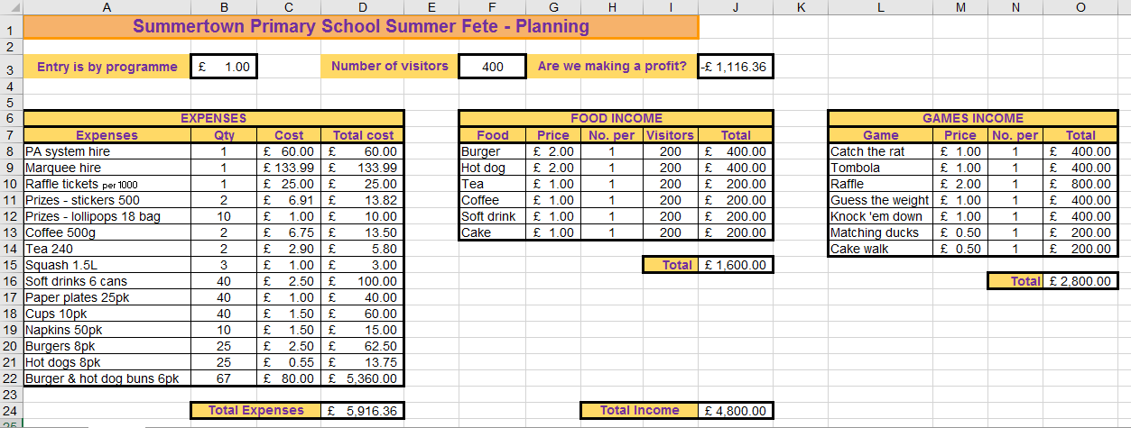

No. | Question | Mark
1 | Write a formula for cell D9. | [1]
=B9*C9

No. | Question | Mark
2 | Write a formula for cell D24. | [2]
=SUM(D8:D22)
Award 1 mark for =D8+D9+D10… etc.

No. | Question | Mark
3 | Write a formula for cell J8. | [1]
=I8*G8

No. | Question | Mark
4 | Write a formula for cell J15. | [2]
=SUM(J8:J13)
Award 1 mark for =J8+J9+J10… etc.

No. | Question | Mark
5 | Write a formula for cell J24. | [3]
=(B3*F3)+J15+O16
Must begin by calculating income from entries, then add income from Food and Games.

No. | Question | Mark
6 | Identify three formats that have been used in this spreadsheet. | [3]
Text enlarged, bold text, background fill, borders (narrow and thick), text centred, values formatted as currency, cells merged.

No. | Question | Mark
7 | What is the value stored in cell B3? | [1]
Price of entry to the fete.

No. | Question | Mark
8 | What value is stored in cell A14? | [1]
Tea 240

No. | Question | Mark
9 | What is a computer model? | [1]
Answer could be: A spreadsheet or computer program that imitates real life and can be used to make predictions about outcomes without actually carrying out the activity.

No. | Question | Mark
10 | What is an advantage of using a computer model? | [1]
Can predict likely outcomes of decisions to give an indication whether a solution will work/be successful.

No. | Question | Mark
11 | Give two examples of situations in real life where computer models might be used. | [2]
Forecasting weather; predicting population growth (schools receive data about local birth rates so they can plan for future school populations); predicting the effects of climate change; a financial model can predict the outcome of planned spending cuts or increases; a financial model can predict if a business will make a profit; predicting spread of disease.

No. | Question | Mark
12 | Give two examples of uses/jobs in real life where spreadsheets might be used. | [2]
Teacher – test scores/calculate predicted grades; lesson register.
Scientist – gather data from experiments; predict rates of change/growth (e.g. spread of disease).
Engineer – predict loads/strains on building materials.
Project management – anyone could use a spreadsheet to create a list of jobs and timeframes for a project.
Accept any reasonable answer.

No. | Question | Mark
13 | Spreadsheet software is rarely sold as a standalone product, it is usually part of an office suite of software. You are probably familiar with Microsoft Excel and Google Sheets, but can you name two other spreadsheet products that are part of a suite? | [2]
Learners will almost certainly look for the Wikipedia answer here.
Below is the list they might choose their answer from.
Source: https://en.wikipedia.org/wiki/List_of_spreadsheet_software

Spreadsheets that are parts of suites
- Ability Office Spreadsheet – for MS Windows
- Apple iWork Numbers, included with Apple's iWork '08 suite exclusively for Mac OS X v10.4 or higher
- AppleWorks – for MS Windows and Macintosh
- WordPerfect Office Quattro Pro – for MS Windows
- EasyOffice EasySpreadsheet – for MS Windows
- Framework – for MS Windows
- IBM Lotus Symphony – freeware for MS Windows, Apple Mac OS X and GNU/Linux
- Kingsoft Office Spreadsheets 2012 – for MS Windows
- Lotus SmartSuite Lotus 123 – for MS Windows
- MarinerPak Mariner Calc – for Apple Macintosh
- Microsoft Works Spreadsheet
- PlanMaker – MS Windows, GNU/Linux, Windows Mobile & CE; part of SoftMaker Office
- Quattro Pro – part of WordPerfect Office
- StarOffice Calc

No. | Question | Mark
14 | Here is a spreadsheet which will return a point score in column C when a grade is entered in column B. All the cells in column C have formulae similar to the one shown.  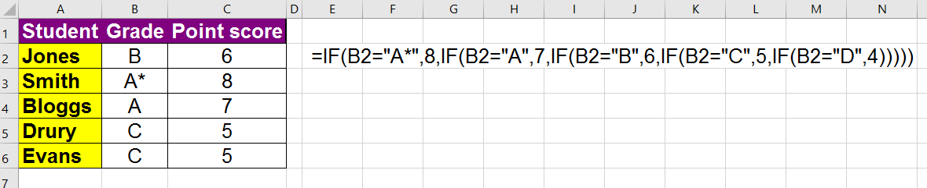  If a grade of E is entered into cell B2 what output would you expect to see? Circle your answer | [1]
- #N/A
- FALSE
- 0
b. FALSE

No. | Question | Mark
15 | Here is a spreadsheet to hold exam marks.  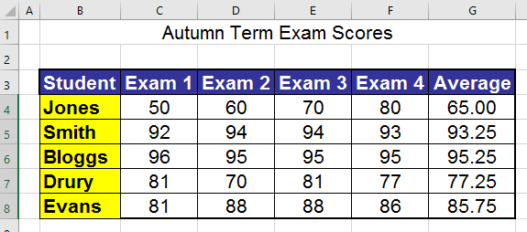 | [2]
- What do you think the formula in column G is doing?
It is calculating an average of the marks achieved in the four exams.
- What do you think the formula looks like? Circle your answer
  - =SUM(C4:F4)/4
  - =AVERAGE(C4:F4)
  - =AVERAGE(C4+D4+E4+F4)
ii. =AVERAGE(C4:F4)
Answer i would also work but is less elegant.

No. | Question | Mark
16 | This spreadsheet is keeping track of donations made to a charity.  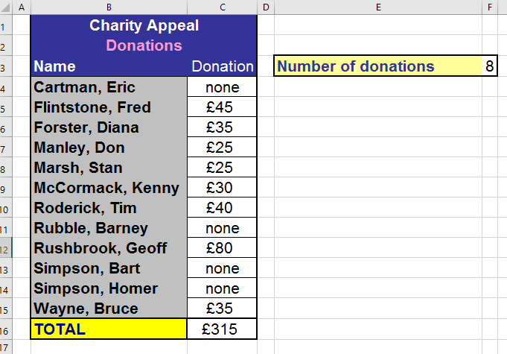 | [2]
  - What do you think the formula in cell F3 is doing?
It is counting the number of cells with numbers in them.
  - What do you think the formula in cell F3 looks like? Circle your answer
    - =COUNT(C4:C15)
    - =COUNTA(C4:C15)
    - =COUNTIF(C4:C15,">0")
i. =COUNT(C4:C15)
Answer iii would also work but is less elegant.

No. | Question | Mark
17 | This spreadsheet holds data about learners and their exam marks.  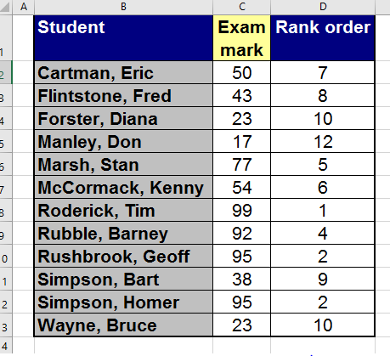 | [1]
What do you think the formula in cell D2 looks like? Circle your answer
  - =RANK(C2,$C$2:$C$13)
  - =RANK(C2,C2:C13)
  - =RANK(C2:C13)
a. =RANK(C2,$C$2:$C$13)
Answer b would also work but because it is not ABSOLUTE it would need to be amended on every following row.

No. | Question | Mark
18 | This table shows a list of employees and their salaries.  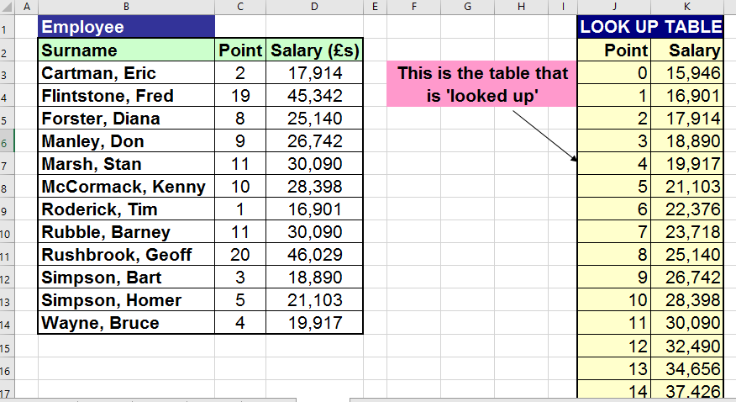 | [2]
For each employee, their point on the payscale is entered (column C) and a lookup formula in column D returns their actual salary. What two advantages are there to using a lookup here?
Reduces user input/error.
Data held in just one place, making it easier to change if necessary.
Any other reasonable answer.

Resources are updated regularly — the latest version is available at: ncce.io/tcc.

This resource is licensed under the Open Government Licence, version 3. For more information on this licence, see ncce.io/ogl.

