Summative assessment – questions

Selection in quizzes
Q1. Why do you use selection in programming?

- To allow the program to flow in different directions
- To make sure the program runs in the correct order
- To perform the same action more than once
- To make sure the program starts the same way for each user

Q2. Draw a box around each program that contains an example of selection.

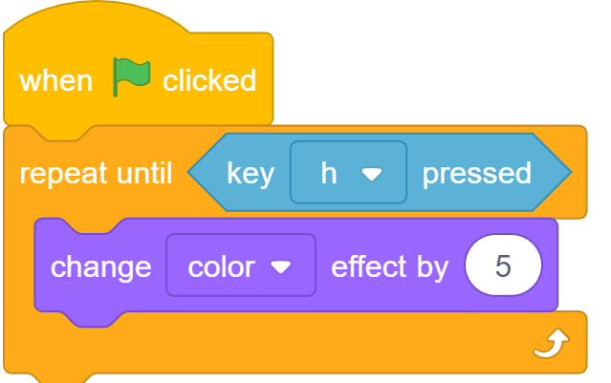 | 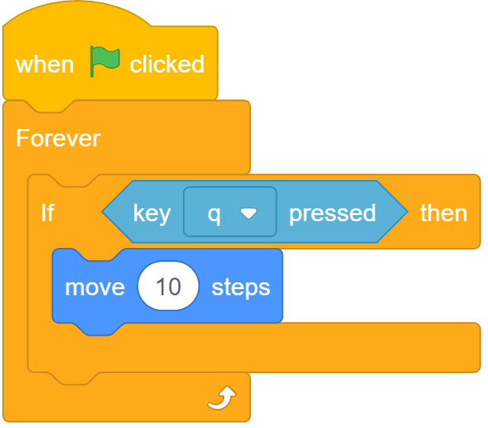 | 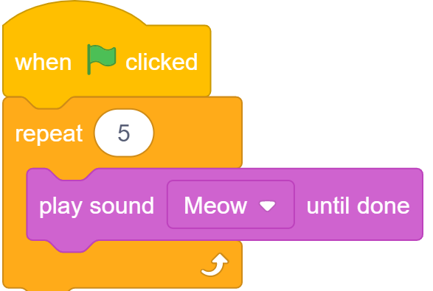 | 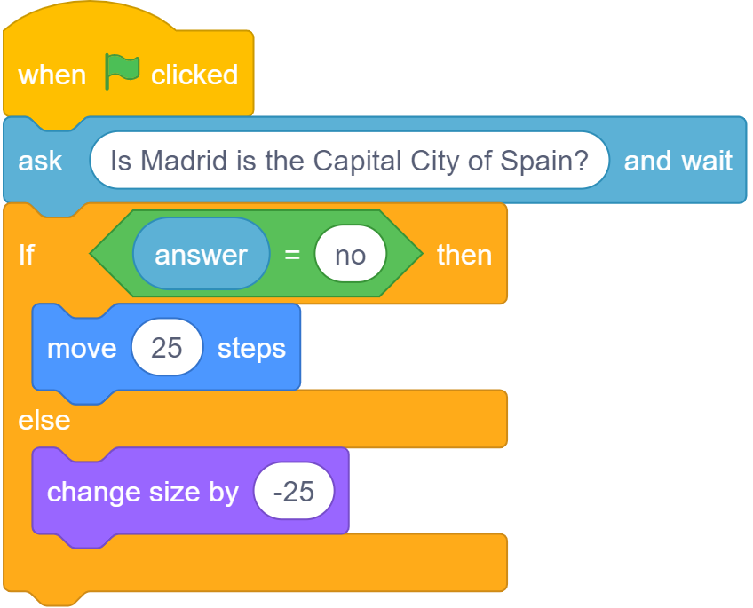

Q3. Tick the box which shows the action that will be carried out when the condition is false.

If it is the weekend
Then go back to sleep
Else
Get up and get ready for school

Q4. What is present in all of these programs?
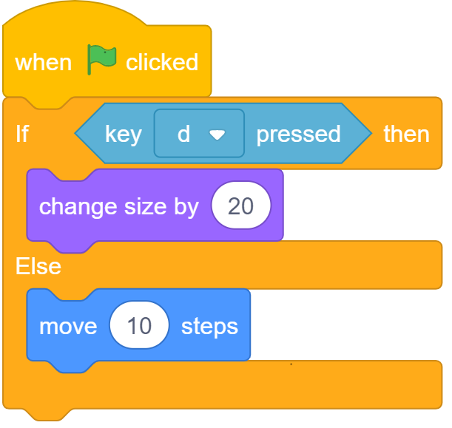 | 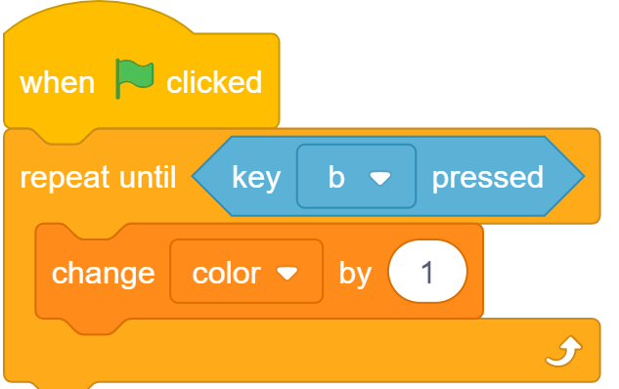 | 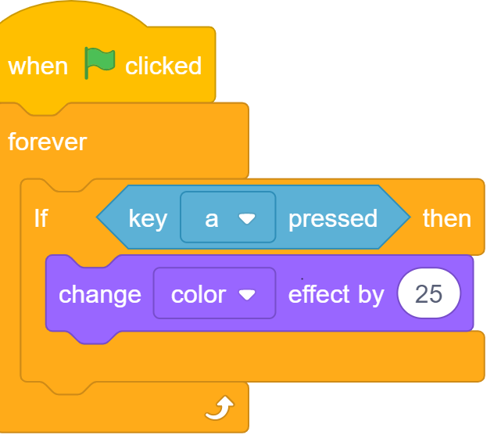 | 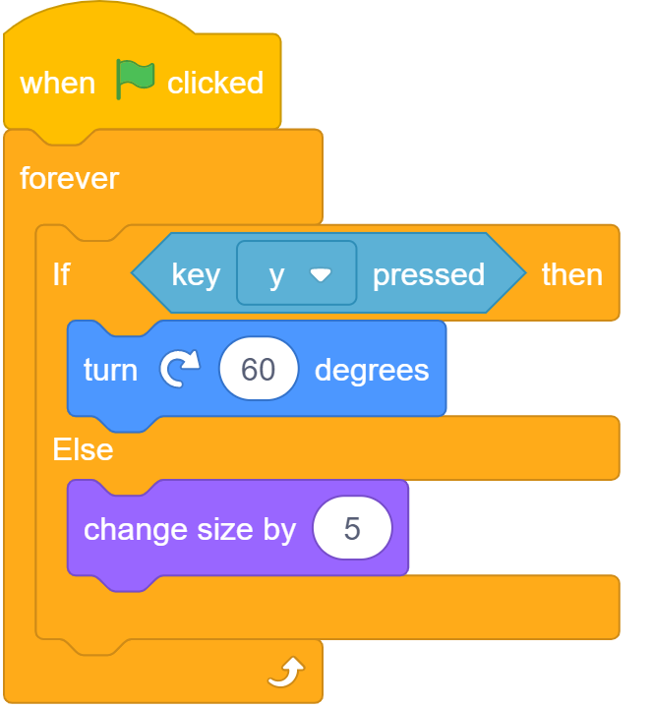
- Selection
- A condition
- Two outcomes
- Repetition

Q5. Draw a box around the program in which there will be an outcome every time key ‘p’ is pressed.

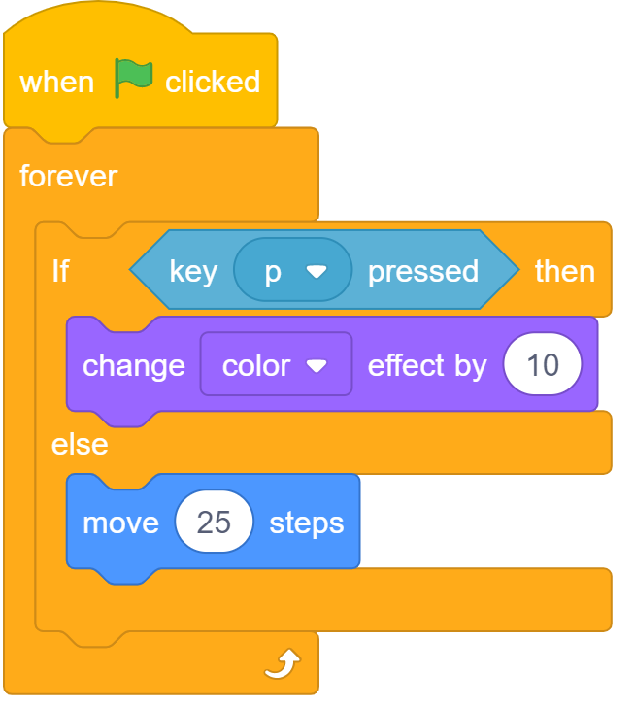 | 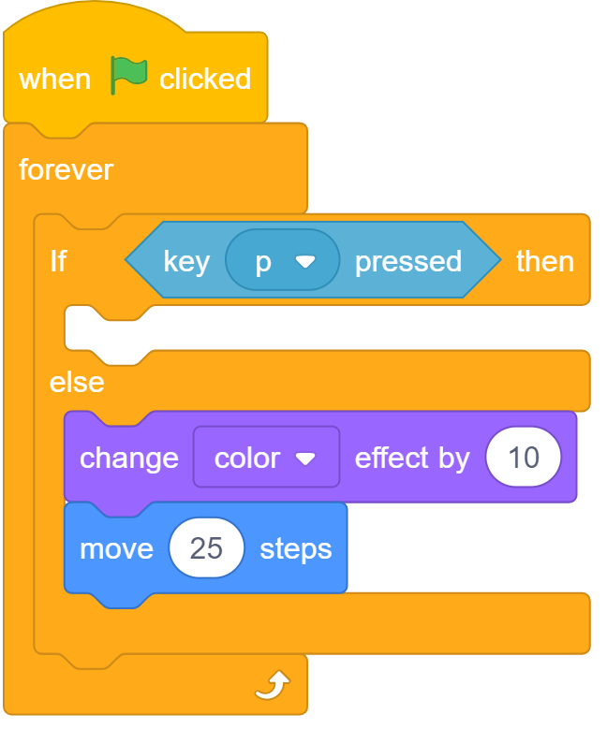 | 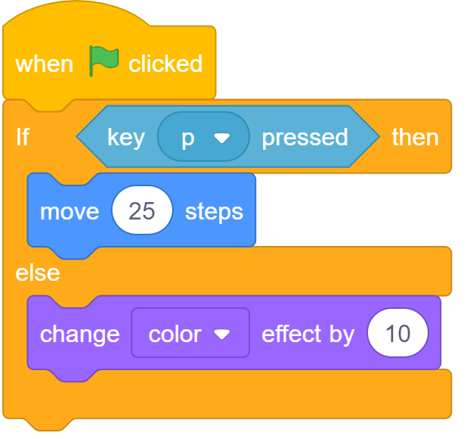

Q6. What will happen if the green flag is clicked to run the program below?

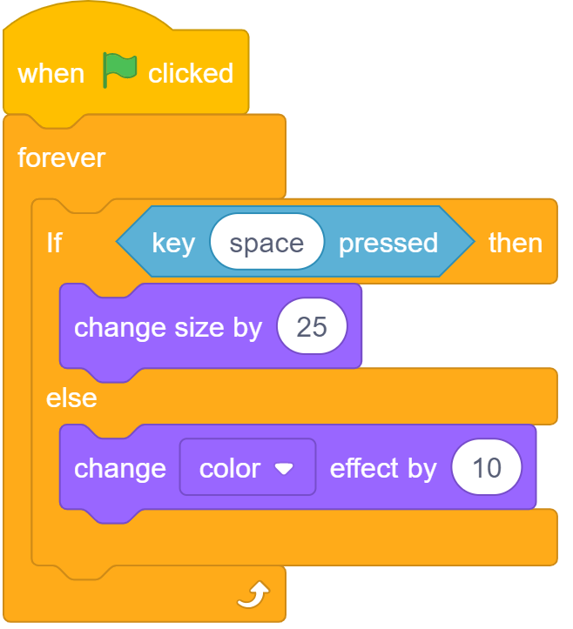

- The sprite will increase in size
- The sprite will change colour once
- Nothing
- The sprite will change colour continuously

Q7. Here is the algorithm for a quiz program. If someone wrote the answer ‘a’ what would the program display on the screen?

Ask the question “What is the first letter of the alphabet?”

Answer is apple

True
False
Display “You’re correct”
Display “Try again”
- You’re correct
- Try again
- Apple
- False

Q8. Follow this algorithm and complete the program by writing in the say blocks.

Ask, “What is 2 x 3?”

Answer is 6

True
False
Display “Well done”
Display “Wrong”

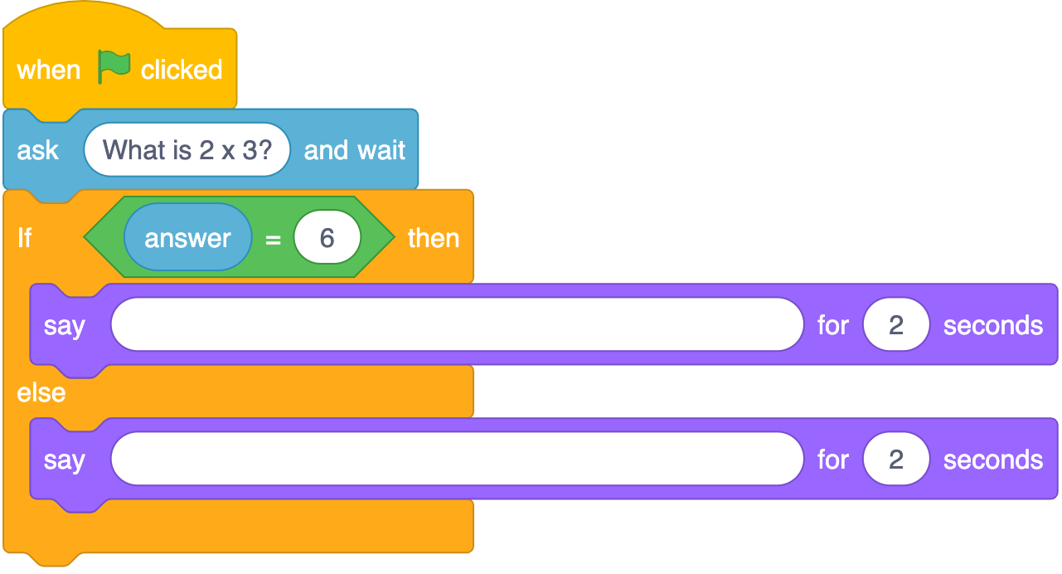

Q9. Tick all the words that would make the program display ‘That’s correct’.

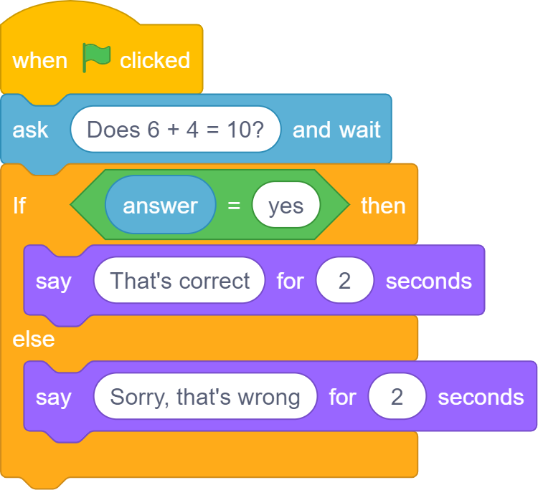

- no
- nope
- yes
- yes!

Q10. Which block(s) would you use for program setup? Tick all that are correct.

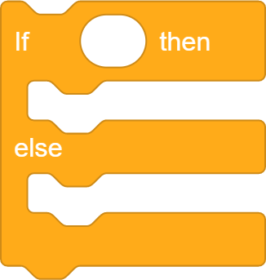

Resources are updated regularly — the latest version is available at: ncce.io/tcc.

This resource is licensed under the Open Government Licence, version 3. For more information on this licence, see ncce.io/ogl.

