Summative assessment – Answers

Variables in games

Q1. Which of these are important features of a variable? Tick all that apply.

- Can be set
- Is a score
- Can be changed
- Has a clear name

The three correct features of a variable are that it can be set, it can be changed, and it should be named. A score is an example of what a variable might be used for, but there are also many other places in a program where they could be used.

Q2. Which data types can a variable hold?

- Numbers only
- Letters only
- Numbers or letters
- Pictures

The correct answer is C. Learners who choose answer A are likely to have the misconception that a value is always numeric. Learners who choose answer B may have the misconception that information is presented in the form of letters or words. Learners who choose answer D have not understood that a variable always holds a value.

Q3. How many values can a variable hold at any one time?

- None
- One
- Two
- Three

The correct answer is B. Learners who choose answer A have not understood that variables hold a value at all times. Learners who choose answer C or D have not understood that the value of a variable is replaced when it is updated. This means that a variable can only ever hold one value at any one time.

Q4. When a variable is changed, what happens to the value?

- It is replaced by a new value
- It is joined by the new value
- It is added to the new value

This question assesses learners’ understanding of the fact that when a value is updated, the previous value is replaced. Learners who choose answer B have not grasped that a variable can only hold one value at a time. Learners who choose answer C may have confused changing a variable by a positive integer (for example, 1) with replacing a value. The correct answer is A.

Q5. In a bat and ball game, which of these parts of the game would be stored using a variable? Tick all that apply.

- Points scored
- Movement of the sprite
- Lives lost
- Time left
- Appearance of the Stage

This question assesses learners’ understanding of aspects of a program that can be set and changed with variables. ‘Points scored’, ‘lives lost’, and ‘time left’ are all variables that learners have explored during this unit. The movement of a sprite is achieved using a simple code sequence and does not involve a variable. The appearance of the Stage is a design choice, which is not linked to any of the programming constructs.

Q6. Imagine that you are storing the score of a football match using a computer program to display to the crowd during the game. Which name would be the best choice for the variable that holds the score of the home team?

- Home score
- Home_score
- Football_match_home_team_score
- Score

Learners who choose answer A have not recalled that the name of a variable should not include a space. Learners who choose answer C have chosen the most detailed answer, but this would be too long to be practical in a project. Answer D does not differentiate between the home team’s score and the away team’s score. The best answer is B, which is brief, does not include any spaces, and contains enough information for the variable to be identified.

Q7. Where is the value of a variable usually set?

- At the beginning of a program
- Throughout the running of a program
- At the end of a program
- When triggered by an event

Learners who choose answer B or C have not understood that the value of a variable is set once, at the beginning of a program. The correct answer is A.

Q8. Which of the following code snippets would create a timer that counts down from 60 seconds to 0?

A. | B.
C. | D.

This is a code reading challenge. The correct answer is D — this will set the timer to 60, and then count down in intervals of one second 60 times. Each of the incorrect answers has one element of the code that would cause a different outcome. Answer A would set the timer to 60, but the timer would count onwards 60 times, to 120. Answer B would appear to stay at 60, although in reality, the program is looping a change by -1 block and then resetting to 60 every second for 60 seconds. Answer C would set the timer to 60, and count down in intervals of one second, but it would then carry on into negative numbers, as the repeat is a forever loop.

Q9. The code snippet below controls the movement of a ball in a game in the style of table tennis. The Stage is also shown next to the code.

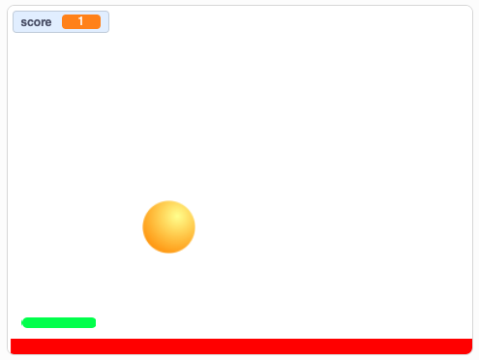

When will the score change?

- When the ball moves
- When the ball touches the paddle
- When the green flag is clicked
- When the ball hits the edge

This assesses how well learners can decompose a more complex code snippet. Learners who choose answer A have misread the move block within the if, then statement; this move block ensures that the ball does not stick to the paddle when it hits it. Learners who choose answer C have confused the set score block with change score. Learners who choose answer D demonstrate that they are unable to recognise variables within code. The correct answer is B, as it is within the if touching paddle then statement.

Q10. What describes the order in which commands are run during a program?

- The algorithm
- The code
- The program flow
- The task

This is the definition of ‘program flow’, which is defined in Lesson 4. Learners who choose answer A have confused the flow of a program with the ‘algorithm’ level of design. Algorithms are clear and unambiguous sets of instructions; they do not define the flow of a program. Answer B refers to the code in a program only, not the flow of the program when it is running. Answer D refers to the ‘task’ level of design; the program flow should enable the task to be met, but the task does not define it.

Resources are updated regularly — please check that you are using the latest version.

This resource is licensed under the Open Government Licence, version 3. For more information on this licence, see ncce.io/ogl.

