Summative assessment – Questions
Q1. Two stars are inputted into a process machine and four are outputted. What is the process that has taken place?

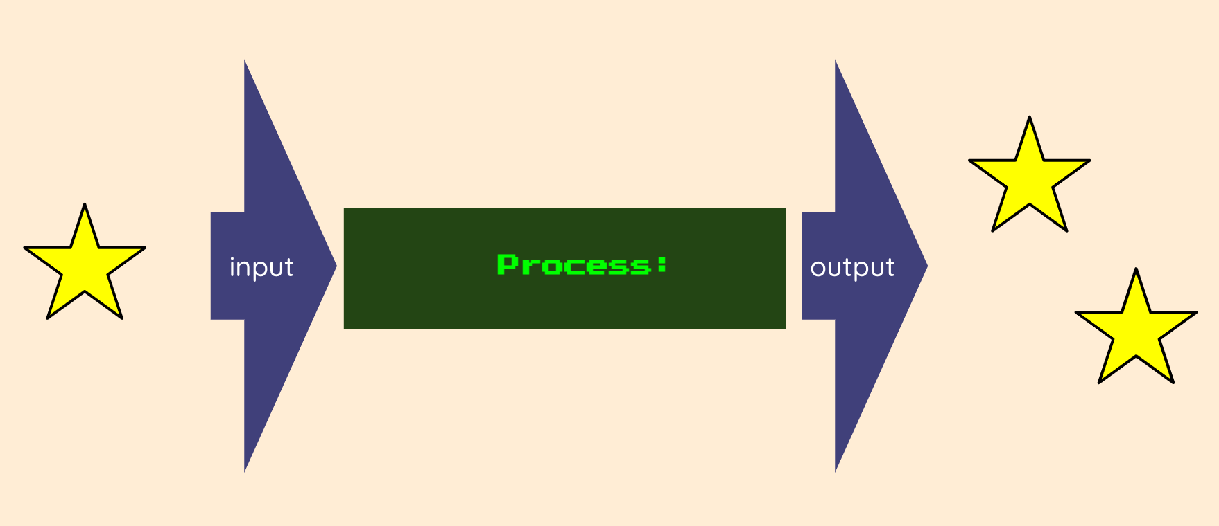

- Three stars have been created
- The stars have been made bigger
- One star has been taken away
- The stars have doubled in quantity

Q2. Which of these is a digital device?

- A lamp | 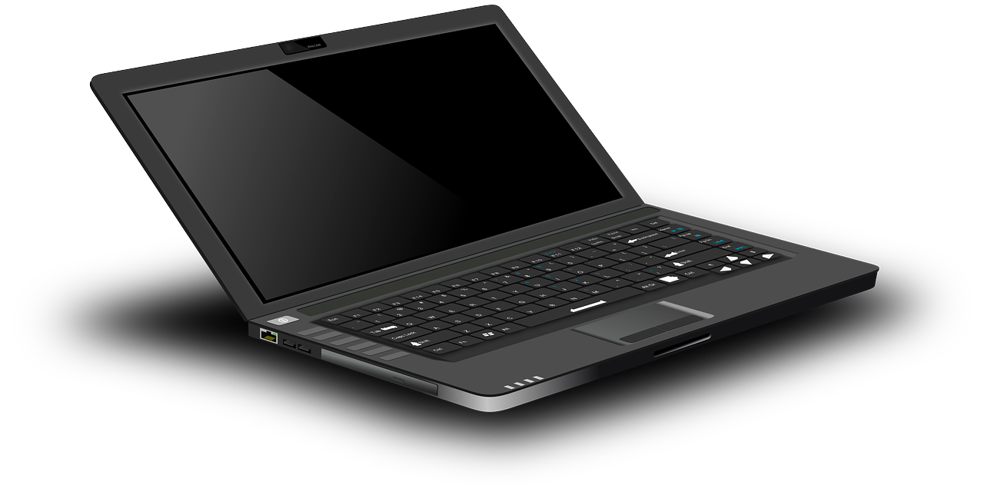  - A laptop computer
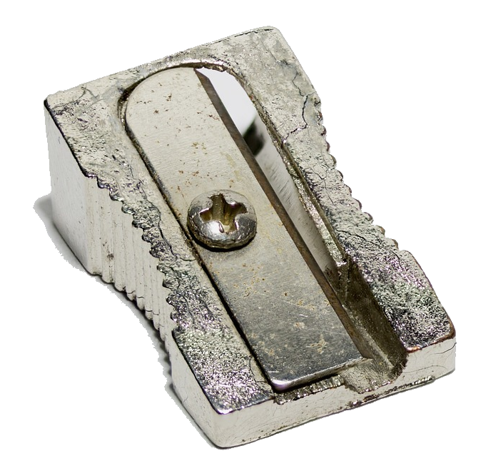  - A pencil sharpener | 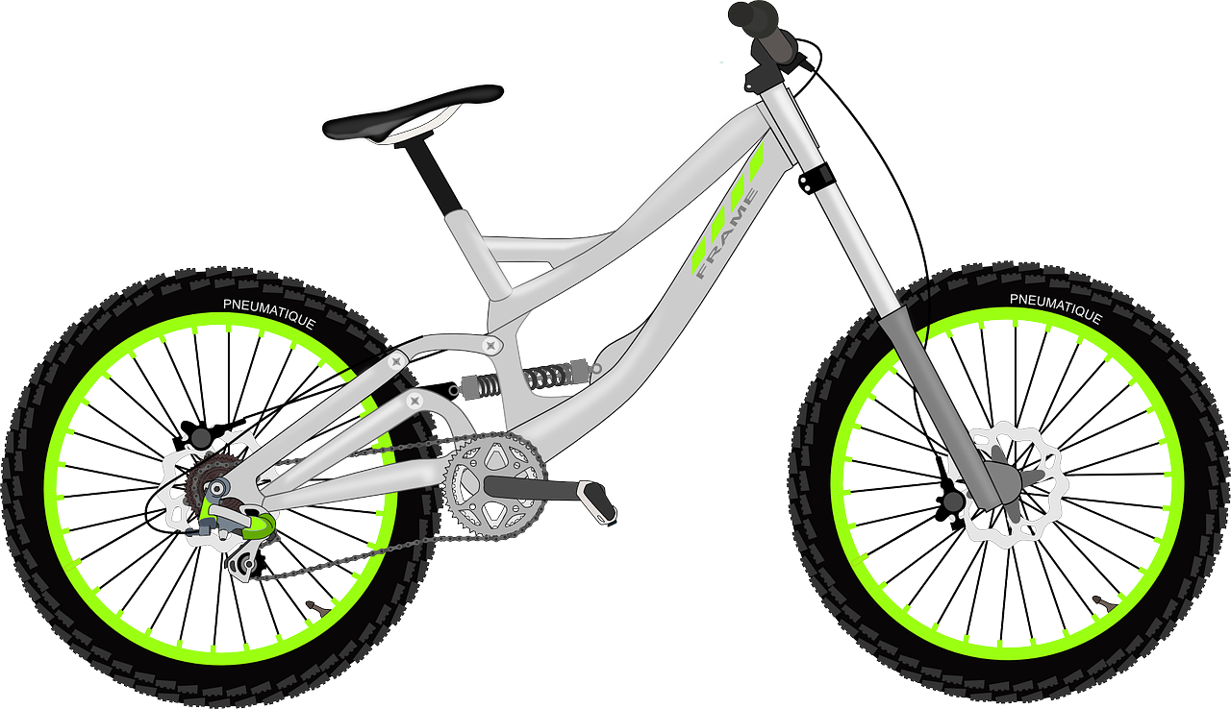  - A bicycle

Q3. Which of these is an input device?

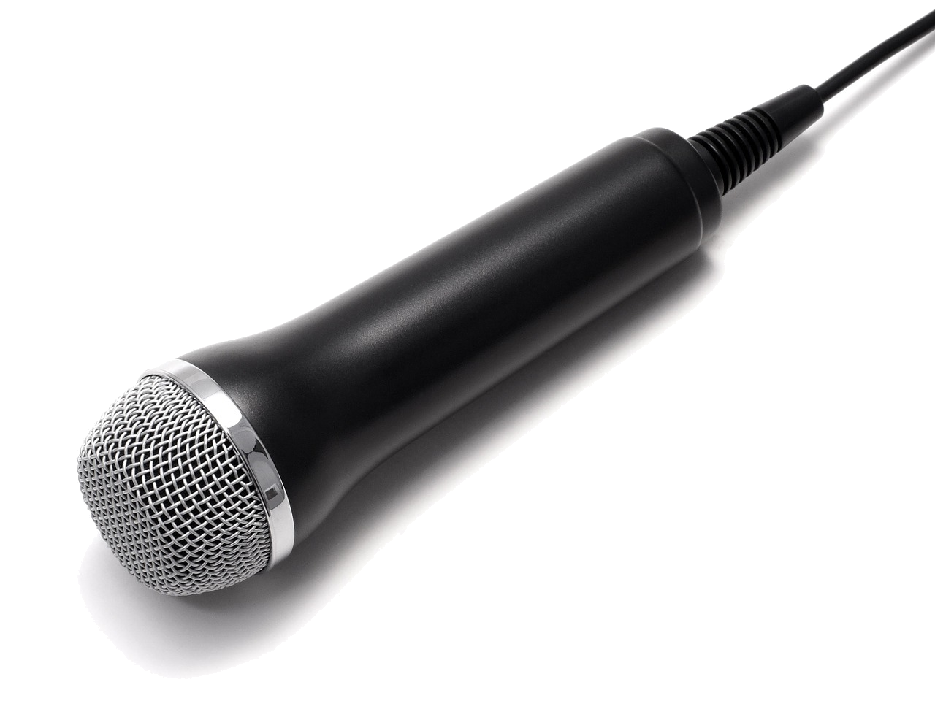  - A microphone | 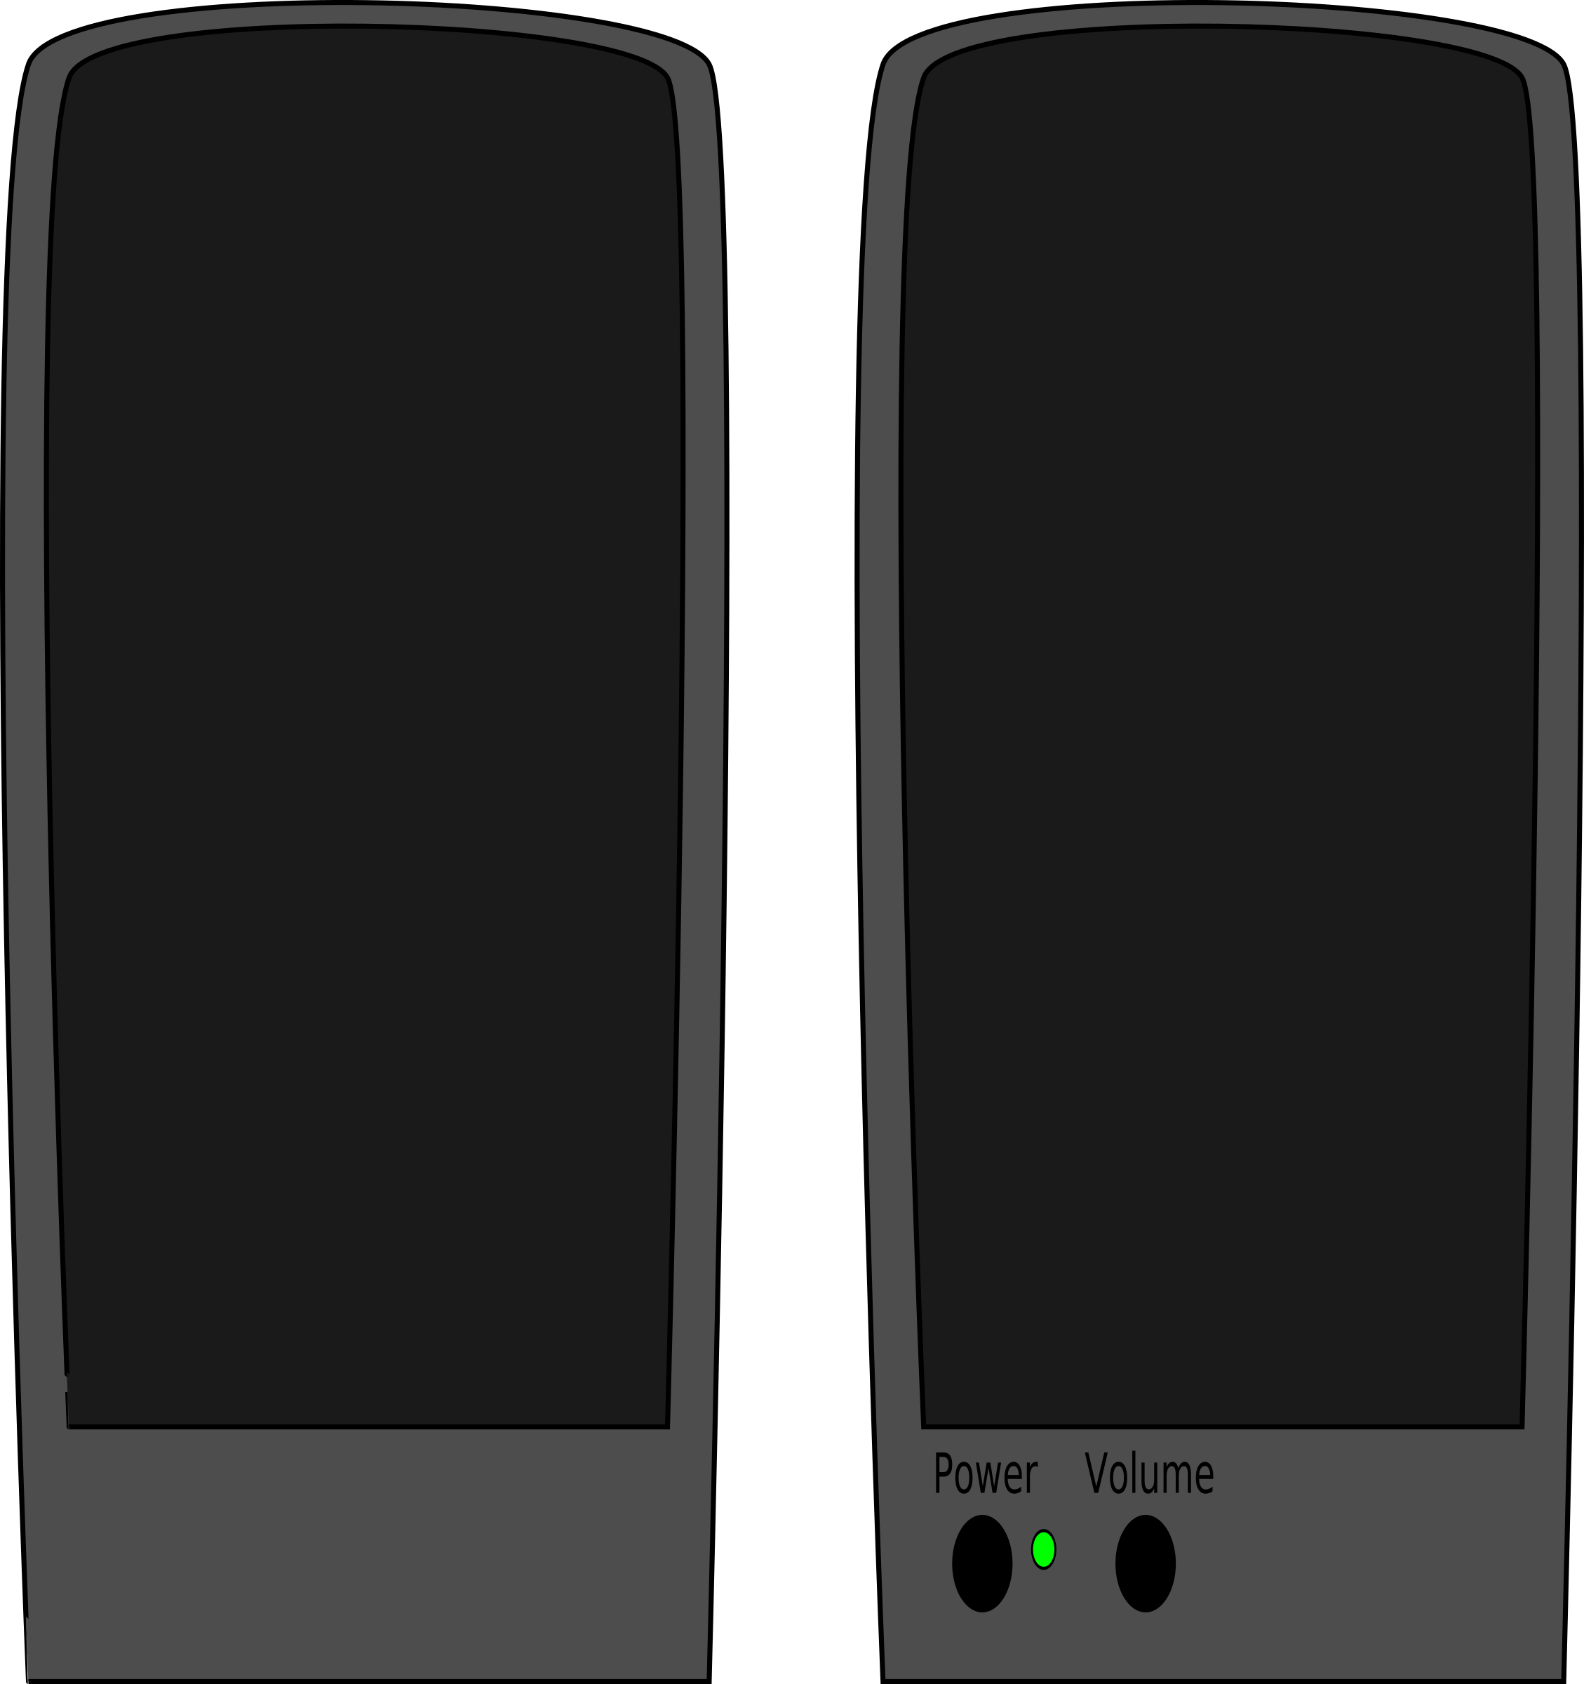  - Speakers
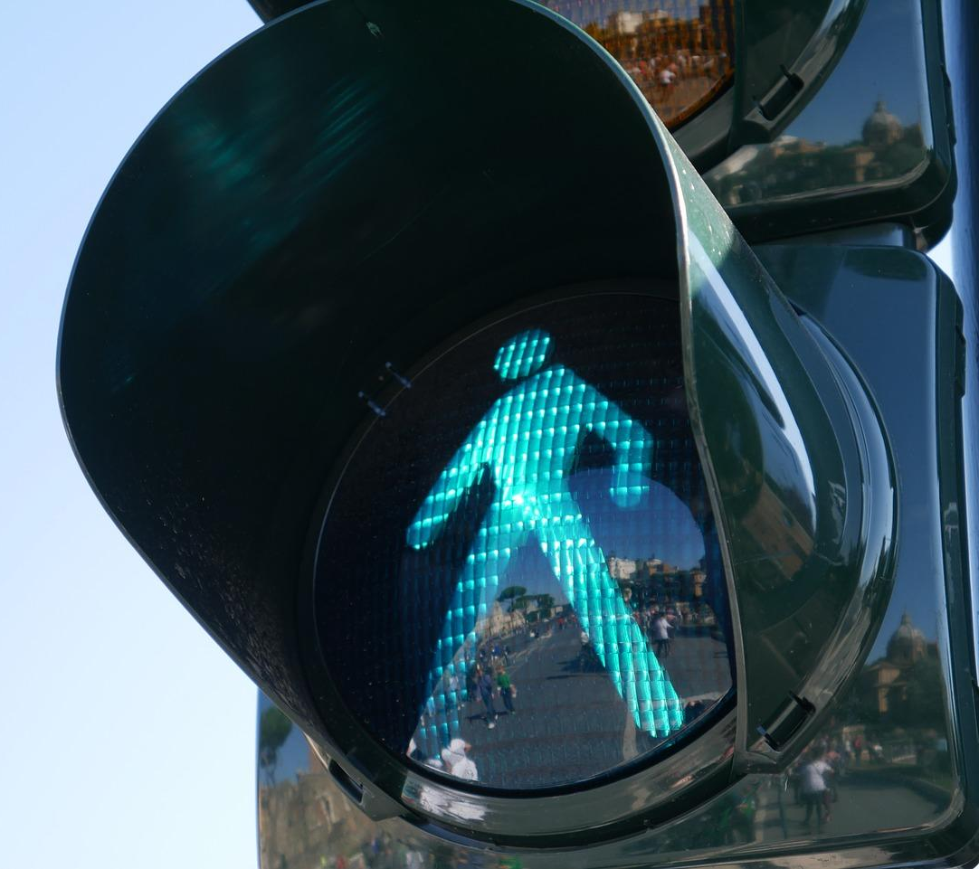  - Traffic lights | 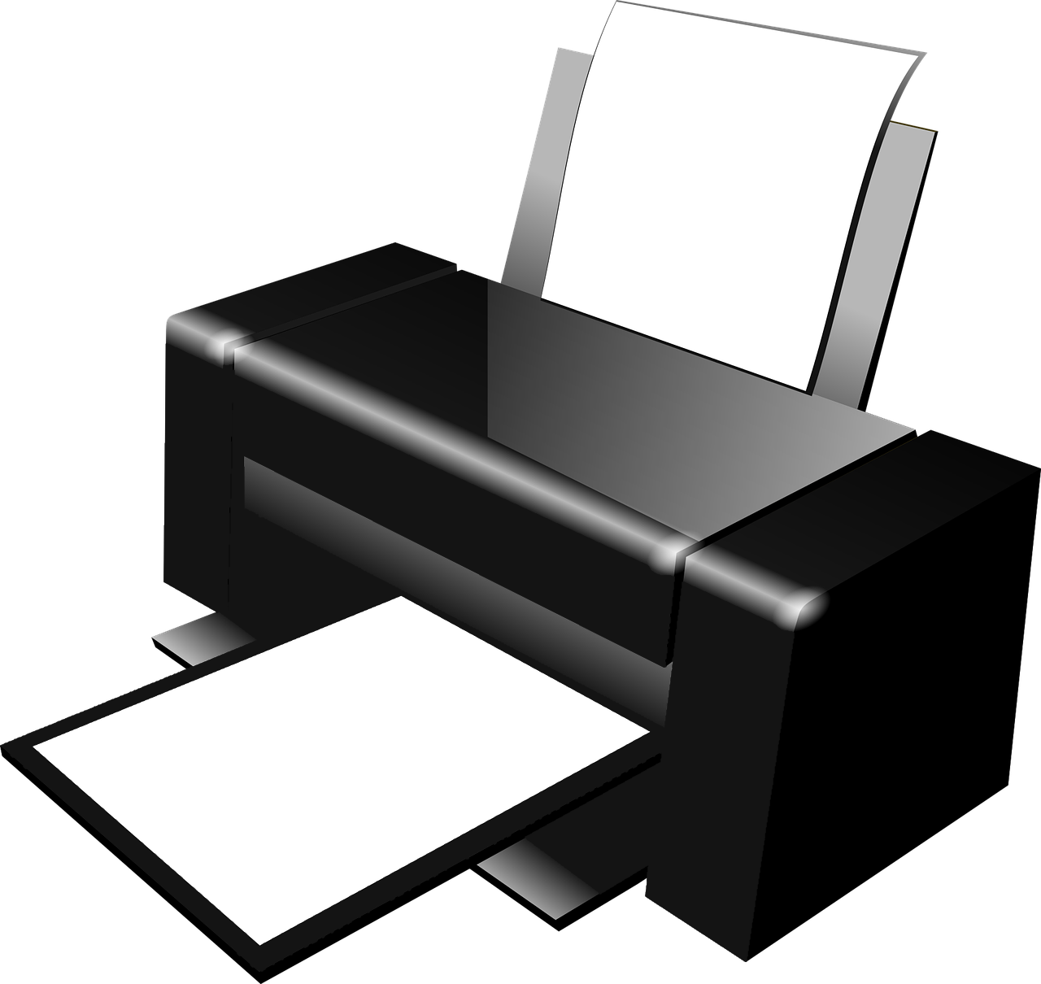  - A printer

Q4. Which of these is an output device?

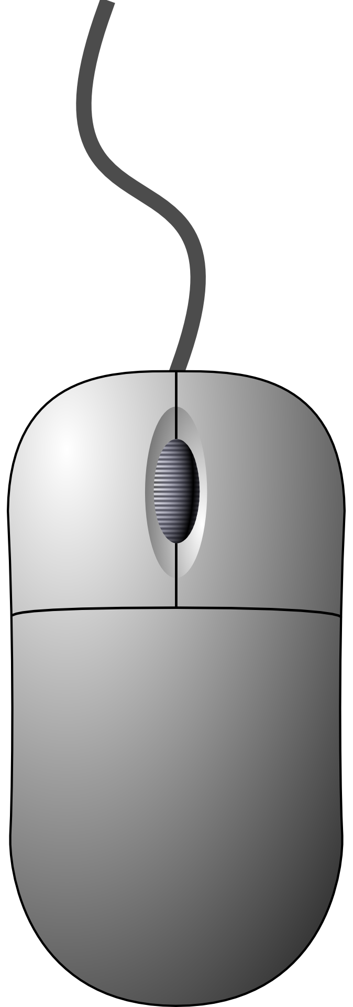  - A mouse | - A button
- A monitor | 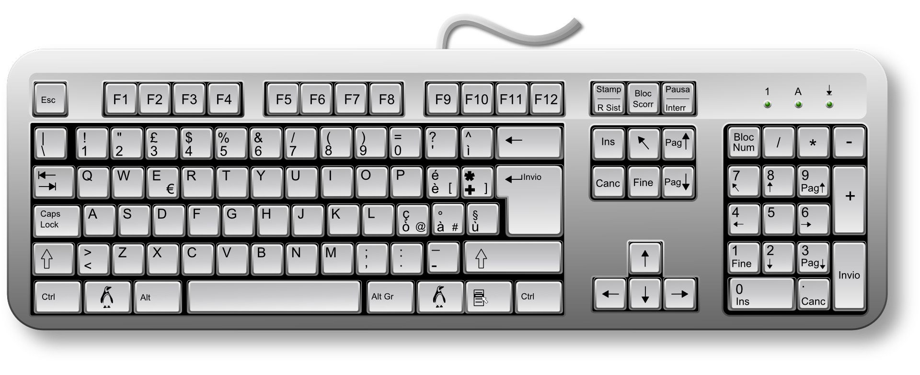  - A keyboard

Q5. Which of these is both an input and an output device?

- A monitor | - Traffic lights
- A touchscreen | - A microphone

Q6. Which of these can you only do using a paint program?

- Undo your previous mark
- Use lots of colours
- Choose a bigger brush
- Show your work to your friends

Q7. What does a network switch do?

- It sends information directly to wireless devices
- It passes information from one computer to another
- It reads messages
- It makes computers work faster

Q8. Why is it a good idea to save work on a server?

- Files can be opened on different computers
- It’s easier to save work
- It makes your computer work better
- It saves money

Q9. Which of these lets you connect a wireless device to a network?

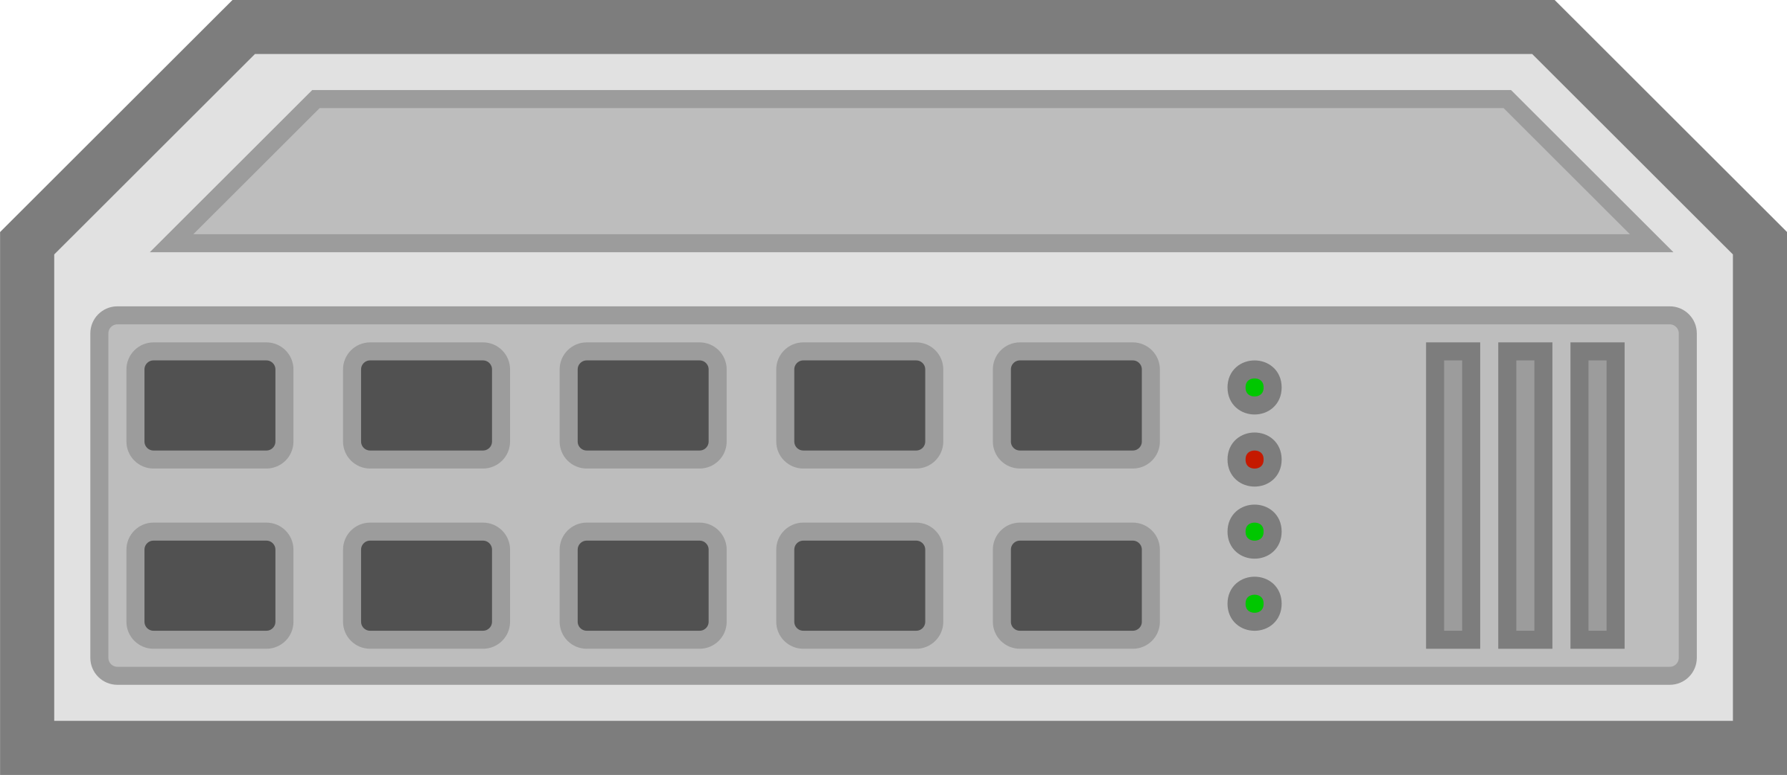  - A switch | 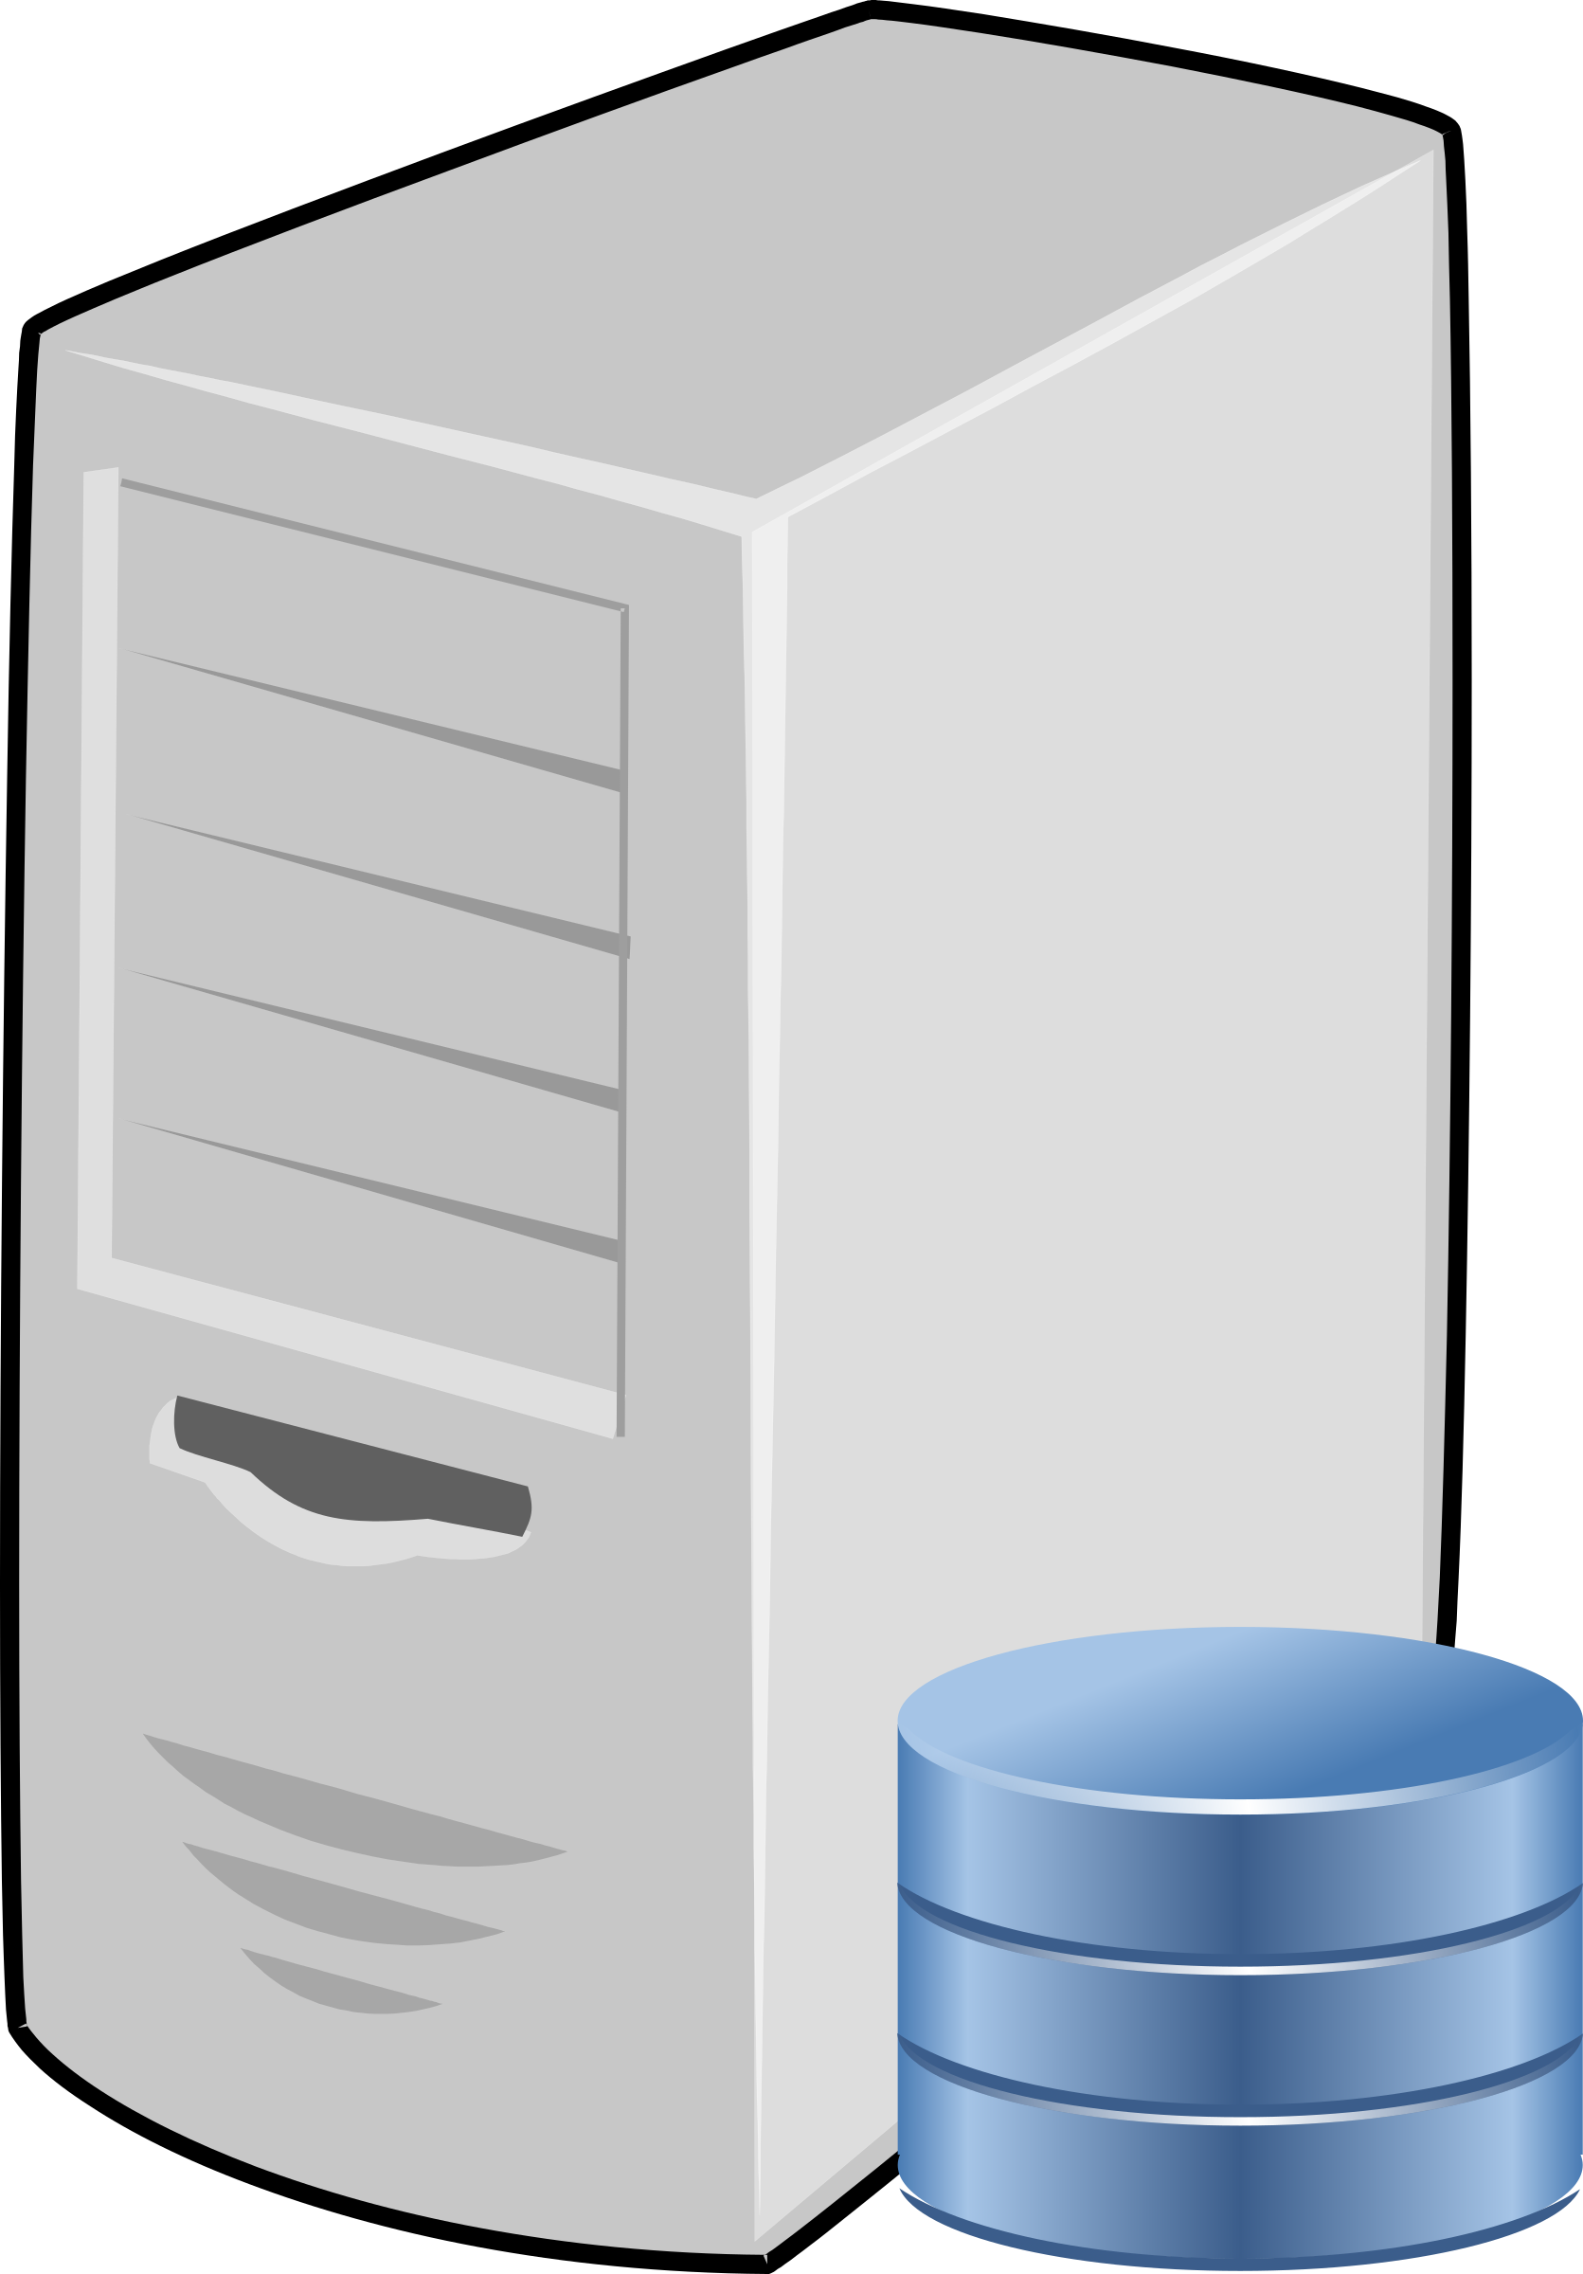  - A server
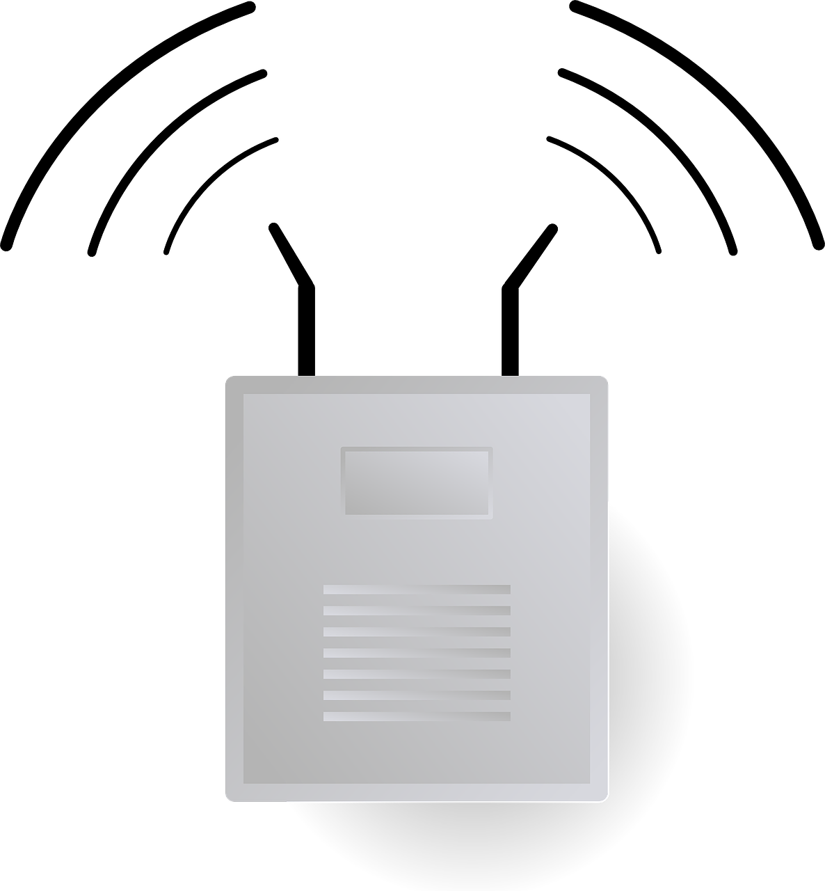  - A wireless access point | 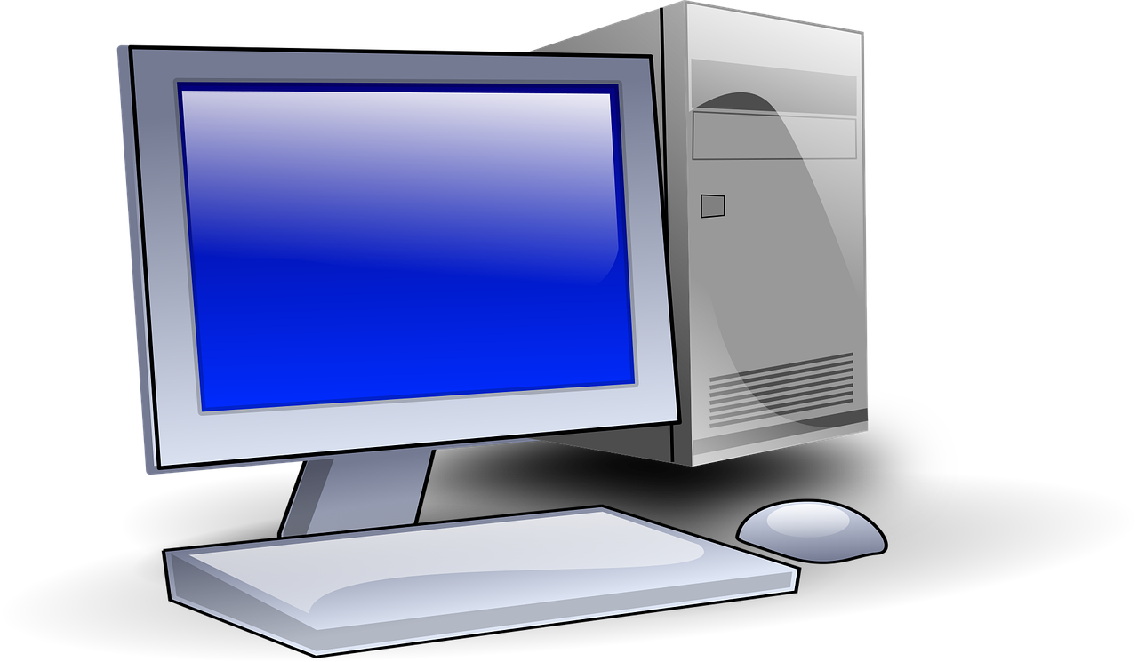  - A desktop computer

Q10. Why is it useful to have a printer connected to a network?

- To save paper
- So that people can share it
- For network connection to work
- So that there are not as many wires

Q11. Which of the following should you NOT use when creating a secure password. Tick all that apply:
  - Capital letters
  - Special characters
  - Family names
  - Random words
  - Birthdays

Image sources:
https://pixabay.com/vectors/desk-lamp-lamp-night-office-red-147523/
https://pixabay.com/vectors/laptop-notebook-mobile-computer-154091/
https://pixabay.com/photos/object-pencil-sharpener-grinder-1675929/
https://pixabay.com/vectors/bicycle-bike-downhill-stumpjumper-161315/
https://pixabay.com/photos/micro-usb-microphone-1335142/
https://pixabay.com/vectors/loudspeakers-speakers-music-sound-29634/
https://pixabay.com/photos/traffic-light-green-light-1024768/
https://pixabay.com/vectors/printer-copier-modern-office-1293116/
https://pixabay.com/vectors/mouse-computer-technology-internet-34688/
https://pixabay.com/photos/london-united-kingdom-678711/
https://pixabay.com/vectors/monitor-display-computer-screen-309582/
https://pixabay.com/vectors/keyboard-keys-computer-hardware-162134/
https://pixabay.com/vectors/african-african-american-black-2029825/
https://pixabay.com/vectors/computer-hub-network-server-switch-159835/
https://pixabay.com/vectors/computer-database-network-server-156948/
https://pixabay.com/vectors/router-wifi-wireless-connector-23240/
https://pixabay.com/vectors/computer-desktop-pc-workstation-1295529/

Resources are updated regularly — the latest version is available at: ncce.io/tcc.

This resource is licensed under the Open Government Licence, version 3. For more information on this licence, see ncce.io/ogl.

