Summative assessment – answers

Selection in quizzes
Q1. Why do you use selection in programming?

- To allow the program to flow in different directions
- To make sure the program runs in the correct order
- To perform the same action more than once
- To make sure the program starts the same way for each user

This question assesses the learners’ understanding of why selection is used in programming. Answer B indicates that learners have not understood that a program can branch according to a condition. Answer C indicates that learners have not understood that conditions can be checked without a loop, for example by asking a question and waiting for an answer. Answer D relates to the setup of a program (initialisation) and does not relate to a user response during the running of the program.

Q2. Draw a box around each program that contains an example of selection.

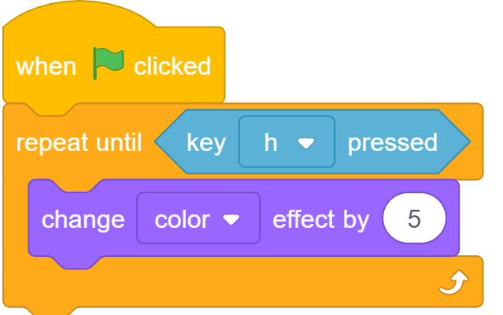 | 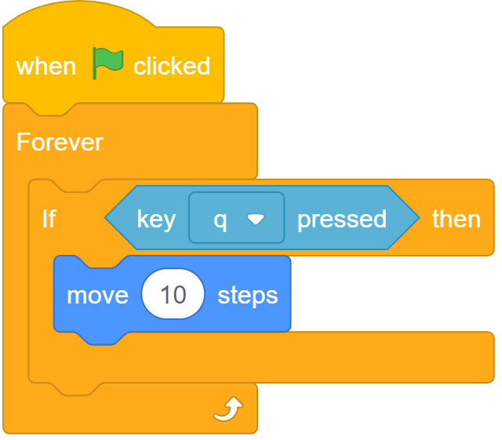 | 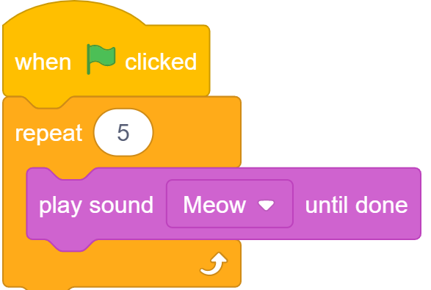 | 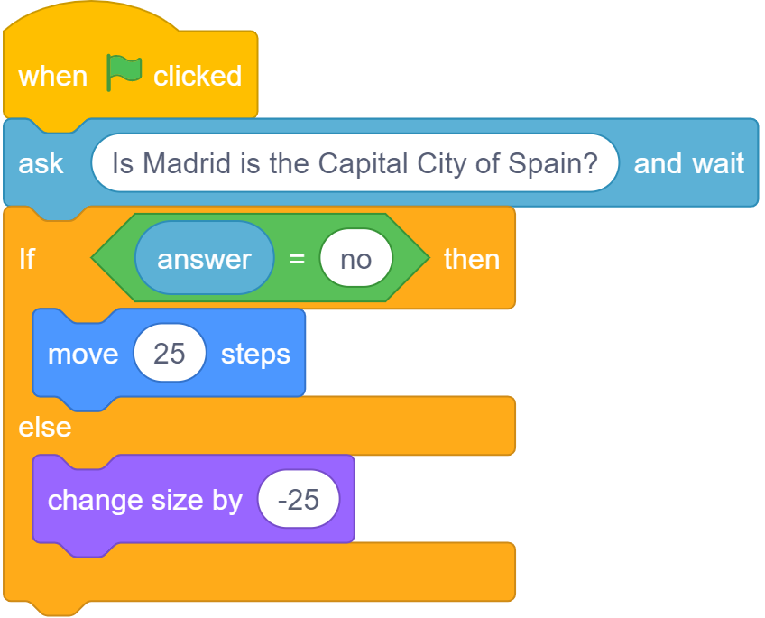

This question is checking that learners can differentiate between programs that use a condition (programs 1 and 3) and programs that use conditions as part of a selection. Learners should use the structures of ‘if… then...’ and ‘if… then… else…’ to identify which programs use selection.

Q3. Tick the box which shows the action that will be carried out when the condition is false.
This question checks that learners understand that when using selection in the structure of ‘if… then… else…’, if the answer is false, the ‘else’ command will run.
If it is the weekend
Then go back to sleep
Else
Get up and get ready for school

Q4. What is present in all of these programs?
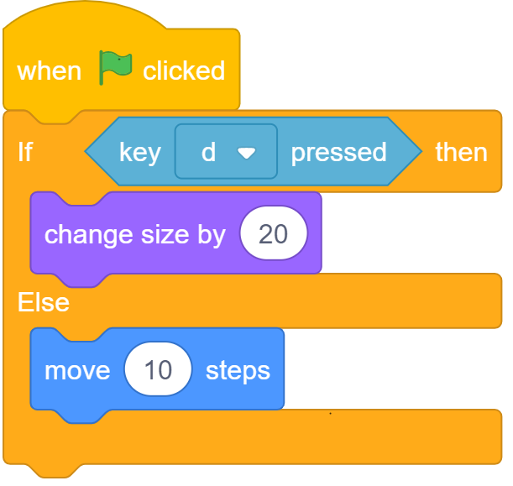 | 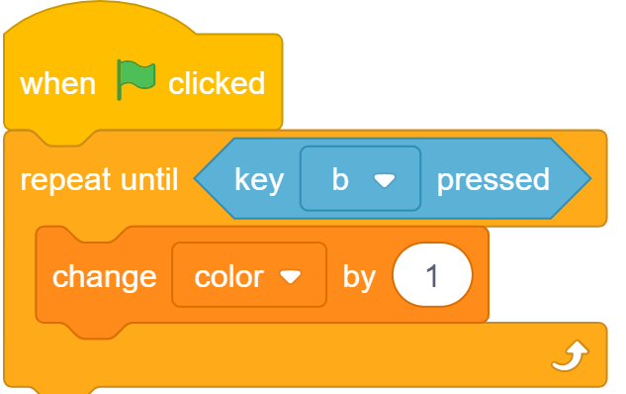 | 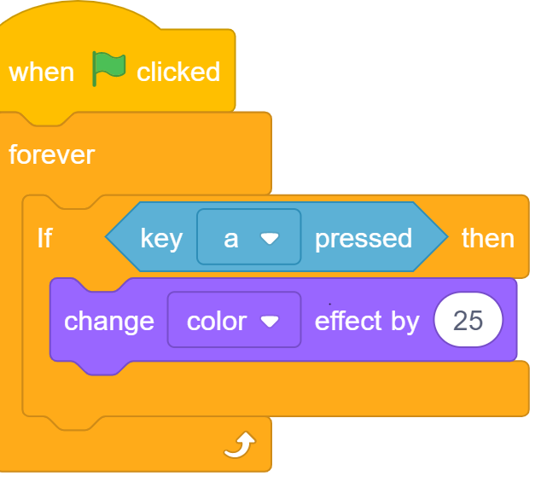 | 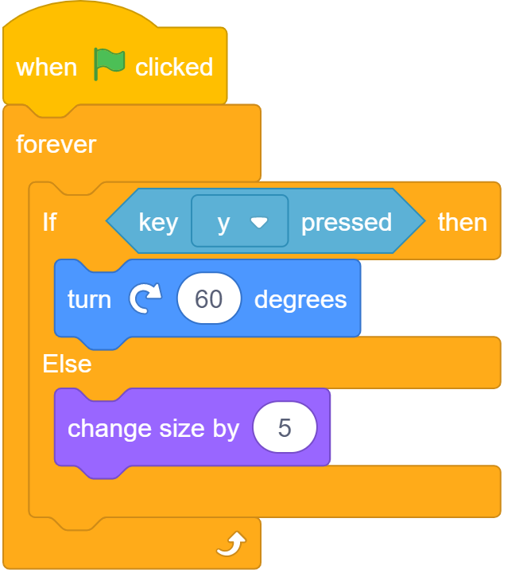
- Selection
- A condition
- Two outcomes
- Repetition

The correct answer is B. This question checks whether learners can identify where conditions are used in a program. Answer A would indicate that learners see conditions as programming elements that are only used with selection. Answer C shows that learners are not tracing through the program to identify the possible outcomes. Answer D indicates that learners are unclear of what repetition looks like in a program.

Q5. Draw a box around the program in which there will be an outcome every time key ‘p’ is pressed.

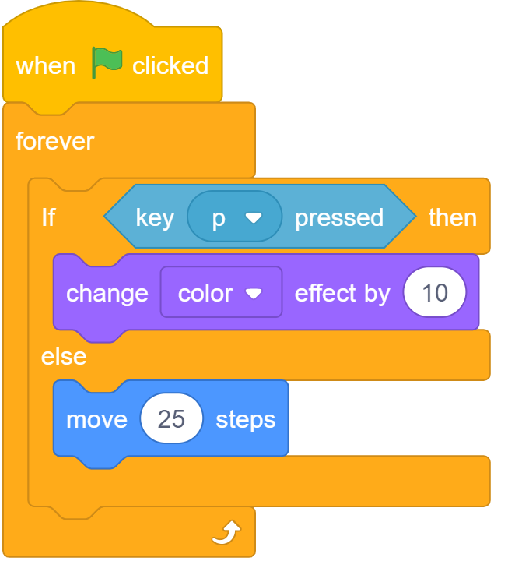 | 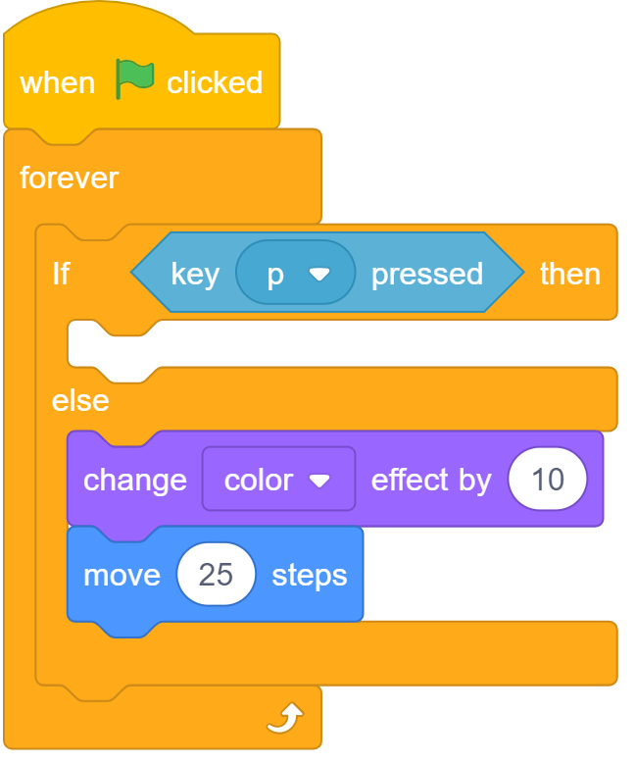 | 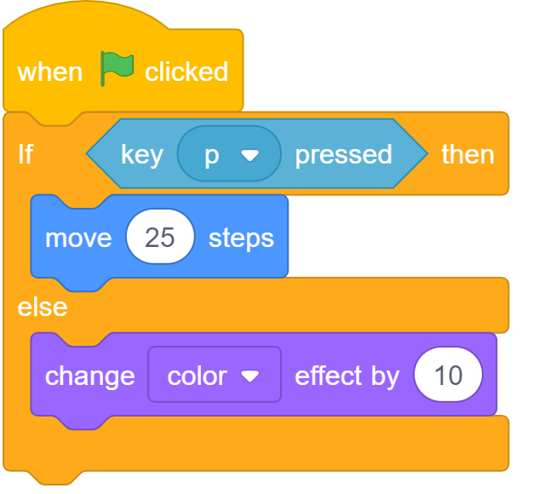

The first program will provide an outcome whenever key ‘p’ is pressed because an infinite loop has been used so that the condition is repeatedly checked and the appropriate outcome carried out. In the second program, although an infinite loop has been used, there is no outcome to be carried out when the condition is true. In the third program, an infinite loop has not been used, so the condition will only be checked once, and therefore the outcome will not be carried out every time the key is pressed.

Q6. What will happen if the green flag is clicked to run the program below?

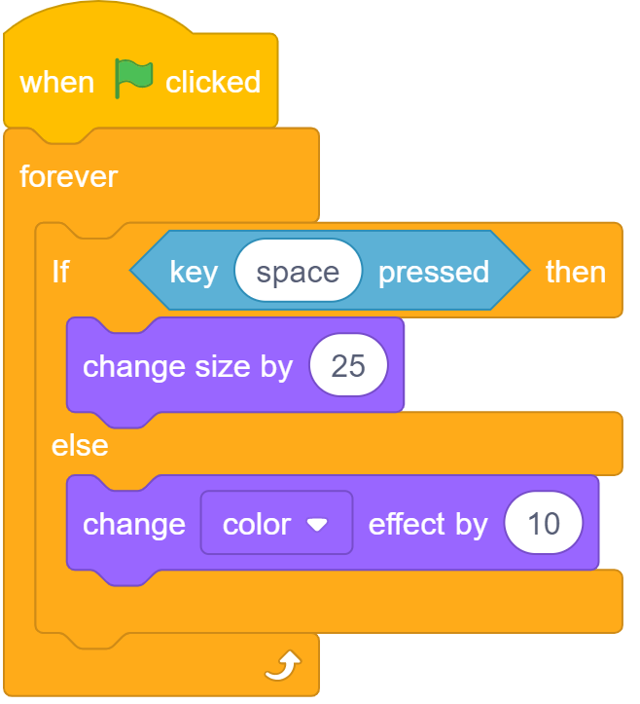

- The sprite will increase in size
- The sprite will change colour once
- Nothing
- The sprite will change colour continuously

This question checks learners' understanding of how programs that include selection in the ‘if… then… else…’ structure will, when used within an infinite loop, repeatedly check if the condition is true or false and carry out the appropriate outcome. Answers A and C would indicate that a learner is only considering outcomes that are carried out when the condition is true. Answer B indicates that the learner is not thinking about the condition being repeatedly checked and the appropriate outcome being carried out.

Q7. Here is the algorithm for a quiz program. If someone wrote the answer ‘a’ what would the program display on the screen?

Ask the question “What is the first letter of the alphabet?”

Answer is apple

True
False
Display “You’re correct”
Display “Try again”

- You’re correct
- Try again
- Apple
- False

This question checks the learner’s understanding of conditions. Namely, that computers do not know whether an answer is wrong or right, and therefore rely on the programmer to write the program correctly. The correct answer is B, because the computer has been told that ‘apple’ is the correct answer, and so ‘a’ would show the ‘false’ response. Answer A suggests that learners have answered the question using their knowledge and not by following the algorithm. Answer C shows an understanding of what makes the condition true, but not which outcome would be displayed. Answer D shows that the learners have identified the correct branch of the algorithm, but not focussed on the question asking what would be ‘displayed’.

Q8. Follow this algorithm and complete the program by writing in the say blocks.

Ask, “What is 2 x 3?”

Answer is 6

True
False
Display “Well done”
Display “Wrong”

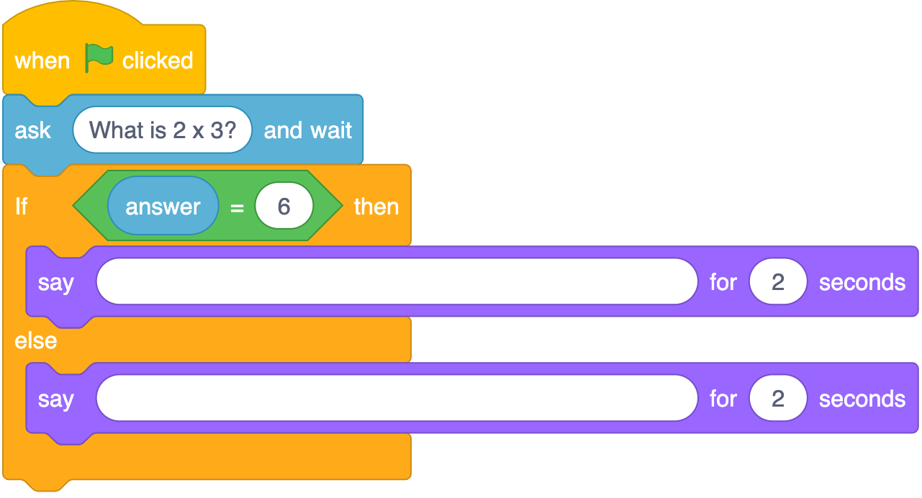

After then, learners should have written ‘Well done’. After else, learners should have written ‘Wrong’. If the learners have reversed these phrases, they do not understand the outcome of ‘true’ and ‘false’ in their programs. If learners have written their own phrases, they have not used the algorithm to complete the program.

Q9. Tick all the words that would make the program display ‘That’s correct’.

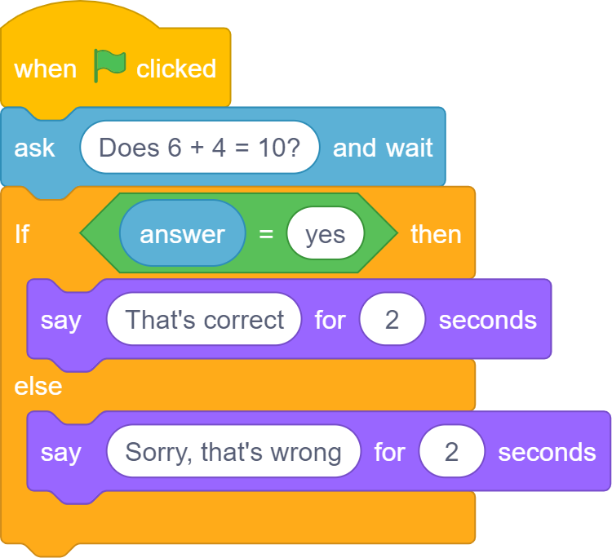

- no
- nope
- yes
- yes!

This question allows learners to show their understanding of how user input can control the outcomes of a program. By selecting ‘yes’, learners show an understanding that the only input that will create a true condition is the word which matches the condition. Answers 1 and 2 suggest that learners can’t trace the flow of commands in a program. The last answer shows a misunderstanding about how a computer interprets punctuation — a word with punctuation is not the same as a word without.

Q10. Which block(s) would you use for program setup? Tick all that are correct.

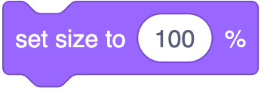
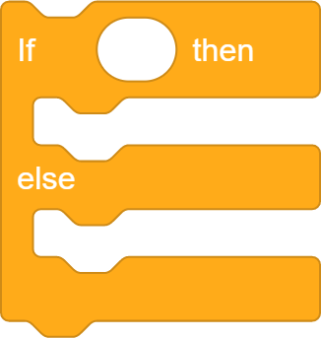

The correct answer is A as this will reset any changes made to the size of sprites as the program is running. B may provide the user a chance to prepare for the start of the program, but it does not reset anything that can change. C and D indicate that learners are unsure which blocks are required to rest the sprite to its previous state.

Resources are updated regularly — the latest version is available at: ncce.io/tcc.

This resource is licensed under the Open Government Licence, version 3. For more information on this licence, see ncce.io/ogl.

