Summative assessment – Answers

1. All data transferred over the internet is broken down into…

- Packets
- Protocols
- Addresses

The correct answer is A. Protocols are an agreed method of communication. In the physical world, you can relate protocols to languages. Addresses are needed for packets to reach their destination, but they are contained in the header of a packet. The data is broken down and included in the data payload of a packet.

2. 192.168.1.15 is an example of….

  - A packet
  - A protocol
  - An IP address

The correct answer is C. As explained in the explanation for the previous answer, a packet is a vehicle for data to be transferred over the internet, and a protocol is an agreed method of communication. Just like a postal address, an IP address directs a packet to its destination.

Questions 3 and 4 relate to this diagram:

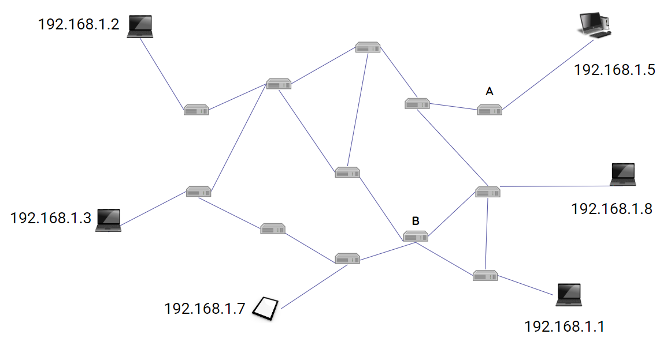

3. Router A breaks. Which device will no longer be able to send or receive messages?

- 192.168.1.5
- 192.168.1.8
- 192.168.1.1

The correct answer is A, the only route for the device labelled 192.168.1.5 to access the network. Were router B to fail, all devices could find alternate routes.

4. How many other routers connect directly to router B?

- 2
- 3
- 4

5. What happens when packets reach their destination?
- They are split into smaller sections
- They are reassembled in the correct order
- They are sent on to another computer

Data is split into small packets to be sent. Once they reach their destination, they go no further and are reassembled into their original form.

Communicating

6. Zara wants to share photos of a birthday party, but only with the people who attended the party. Which method of communication should they use?

- Blog post
- Telephone call
- WhatsApp message

Because the question references photos, a visual method of communication is required, which rules out a telephone call. Photos can be shared on blog posts, but typically they are public, so WhatsApp is the best option.

7. Harris wants to publicly share a piece of writing that a student has written about a school trip. Which method of communication should they use?

- Blog post
- WhatsApp
- SMS

WhatsApp and SMS are both private methods of communication typically used to share short messages and/or images. Blog posts are better suited to sharing longer pieces of writing with many people.

8. When two people collaborate online, which of these statements is correct?

- They both need to be working on the same computer
- They both need to be working on the same network
- They both need to be working on the internet

When people collaborate online, they both have to be working on the internet. There is no requirement for them to be on the same computer or the same network.

9. Which of the following is an example of when you are allowed to use someone else’s work, without asking for permission?

- Copying text from a website
- Remixing a Scratch project
- Downloading a YouTube video

10. Which of the following packets is complete and will successfully reach its destination?
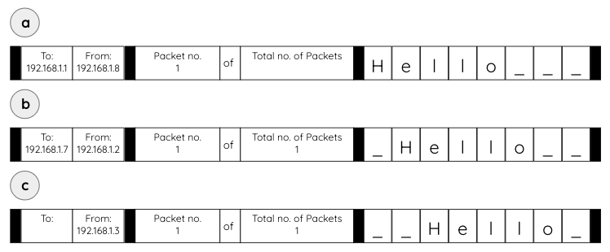
- a
- b
- c

Packet A is missing the value for ‘total number of packets’ therefore the packet will not send as the sending computer will not know if the message is complete. Packet C has no IP address in the ‘To’ field, so the sending computer will not know where to send the packet to. Packet B is complete. The location of the letters in the packet has no influence on whether or not the packet will be sent successfully.

Resources are updated regularly — the latest version is available at: ncce.io/tcc.

This resource is licensed under the Open Government Licence, version 3. For more information on this licence, see ncce.io/ogl.

