Summative assessment answers

Branching databases
Q1. Which of these questions could be used in a branching database?

- What is your favourite colour?
- How many dinosaurs are there?
- Is it bigger than a tennis ball?
- What is the first day of the week?

The correct answer is C as this is a yes/no question. Answer B suggests that learners are confusing this type of data organisation with something like pictograms that show quantities of data. Answers A and D have a finite number of answers, however, a branching database needs just two answers to a question (yes/no).

Q2. Which question(s) could be used to separate these shapes into two groups? Tick all that apply.

- Is it black?
- Is it a circle?
- Is it a shape?
- Is it big?

The correct answers are A and B as they would both allow the group to be split into two smaller groups. Answer C has shown that learners recognise the category of the group but not how these categories are used in a branching database. Answer D shows that learners haven’t thought about the answer to the question as all of the objects are the same size and so it is impossible to make two groups.

Q3. Which of the shapes does not share a common attribute with any of the others?

- The black circle
- The white square
- The grey circle
- The black triangle

The correct answer is B. The black and grey circles share the common attribute of ‘shape type’, which is ‘circle’. The black circle and the triangle share the common attribute of ‘colour’, which is ‘black’.

Q4. What would be the best question to separate this set of objects?

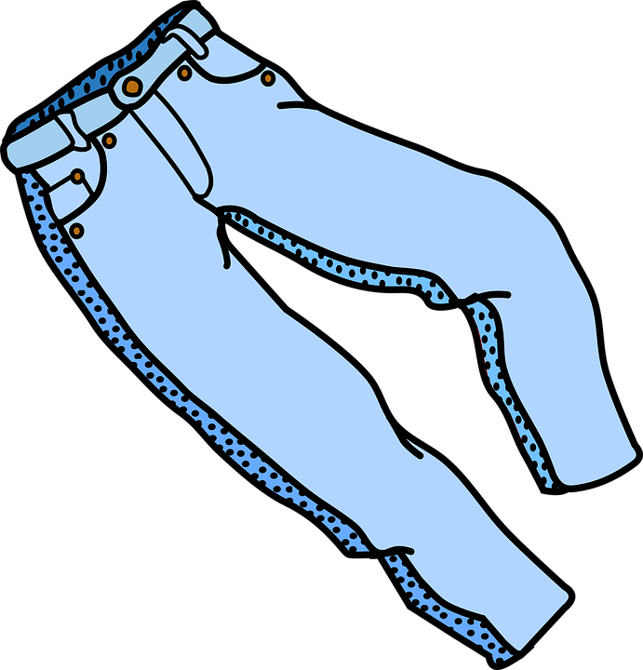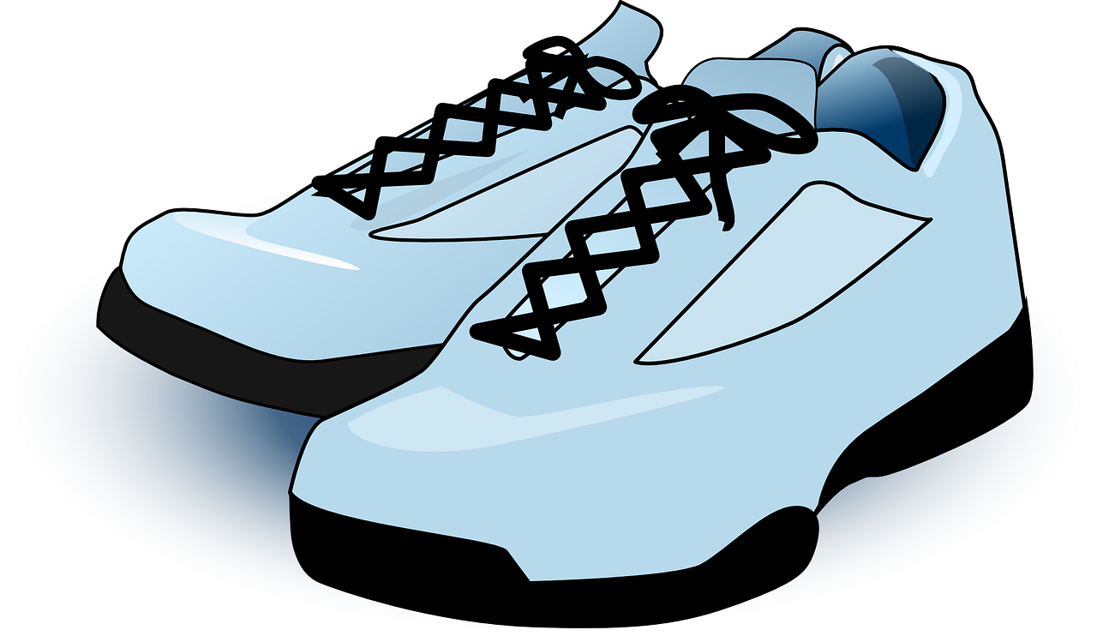

- Does it have a button?
- Does it have long sleeves?
- Does it have more than one pocket?
- Does it have laces?

The correct answer is A. Other answers show that learners are not considering how the objects will separate when the question is being answered. All the other answers will create a group of 1 and a group of 3. For example, answer D will branch off the trainers from the other three objects.

Q5. What attribute(s) do these objects not have? Tick all that apply.

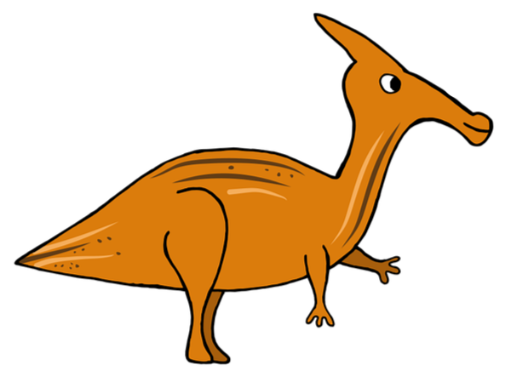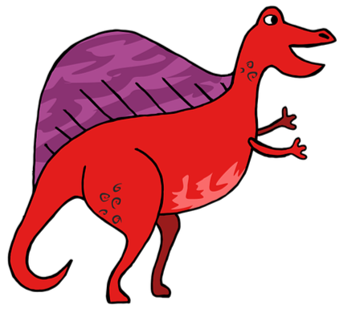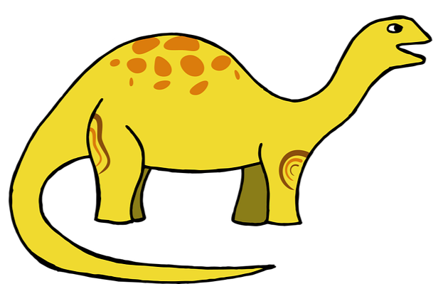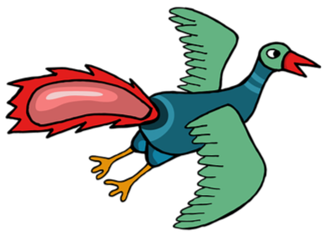

- Legs
- Wings
- Wheels
- Back fin
- Stripes

The correct answers are ‘wheels’ and ‘stripes’ as none of the objects shown have these two attributes. At least one of the objects has the other attributes listed, for example the second object has a back fin.

Q6. Where would these objects be placed in the branching database?

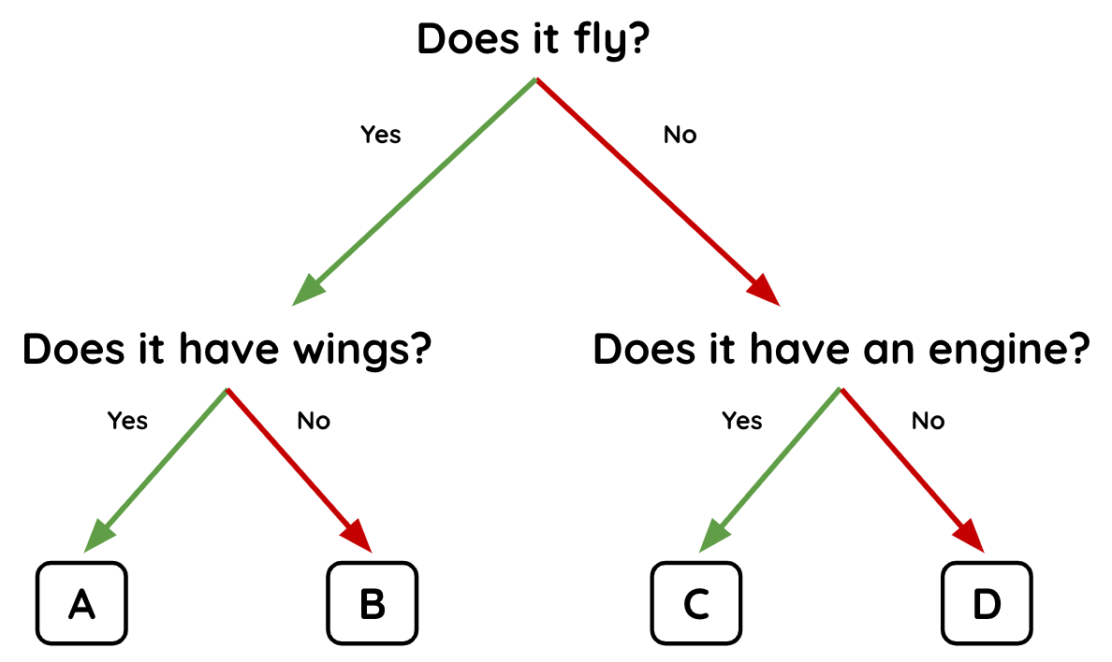
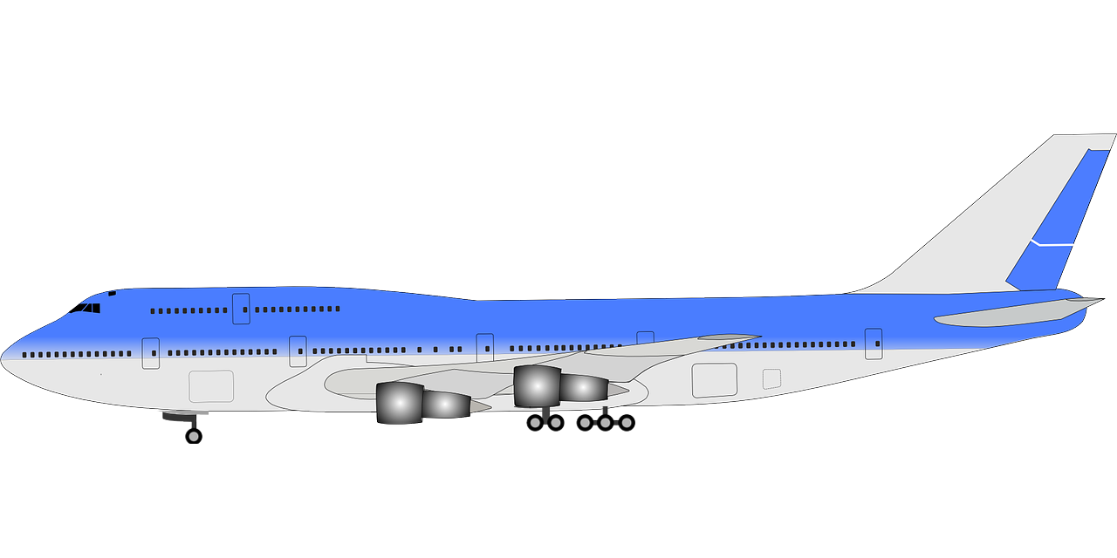 | - A  - B  - C  - D
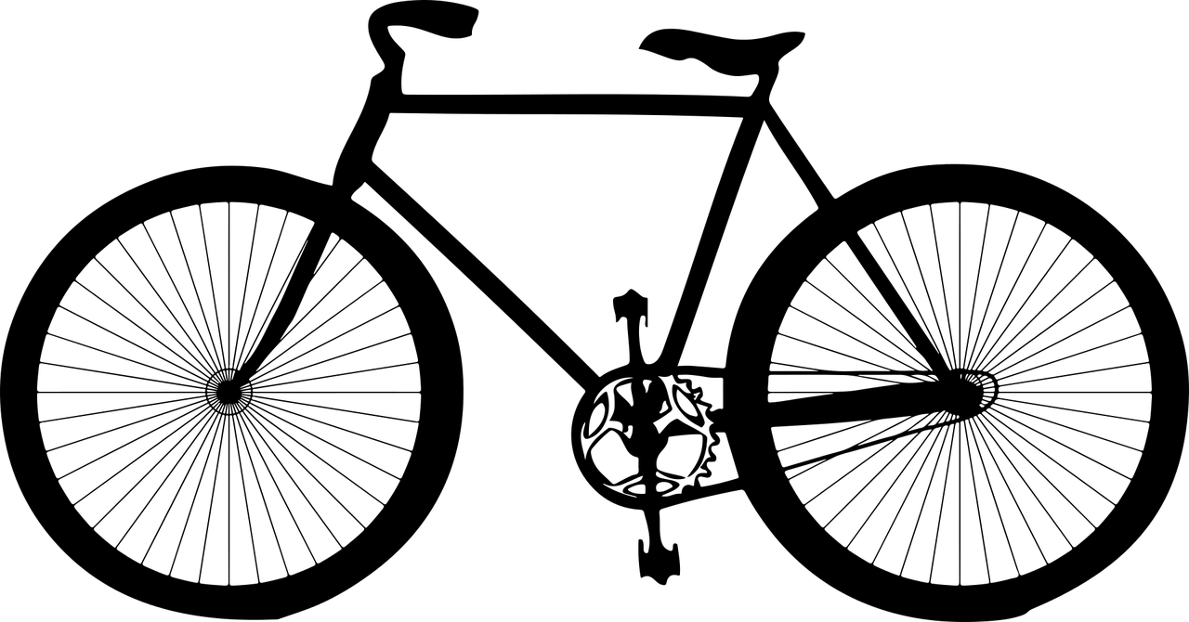 | - A  - B  - C  - D

The correct answer for the plane is A. The correct answer for the bicycle is D. Other answers show that the learners are not following the branching database correctly.

Q7. Circle 3 mistakes in this branching database.

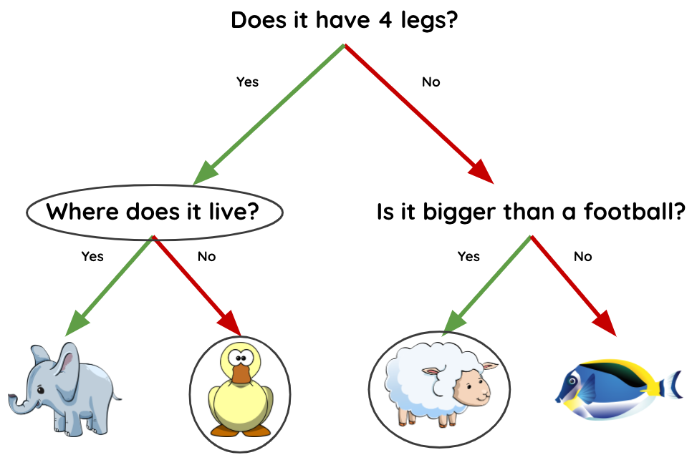

The three mistakes are circled on the branching database above. The question is wrong as it does not require a yes or no answer. The duck and sheep are mistakes as they have both been branched the wrong way from the first question of the database.

Q8. Which of these best describes the structure of a branching database?

- Graph
- Tree
- Branch
- Table
- List

The correct answer is B. Answer C shows that learners do not recognise that a branching database has to have at least two branches (yes/no) which give the database its tree structure. Answer A suggests that learners may have confused pictograms and branching databases as ways to organise data. Answer D and E are structures used in other kinds of databases such as a flat file database, but would not be appropriate for a branching database.

Q9. Where does the question “Does it float?” fit into this branching database?

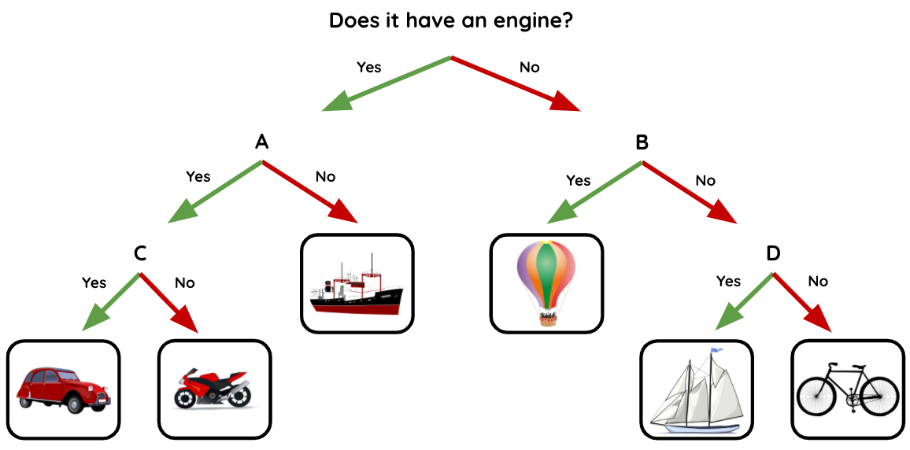

- A
- B
- C
- D

The correct answer is D. If learners put the question in position A, the ship would be positioned incorrectly. If they put the question in position B, the boat would be positioned incorrectly. If they put the question in position C, the car would be positioned incorrectly. If learners have chosen an answer other than D, it is likely that they have not followed the branches all the way through.

Q10. Which branching database is least well structured?

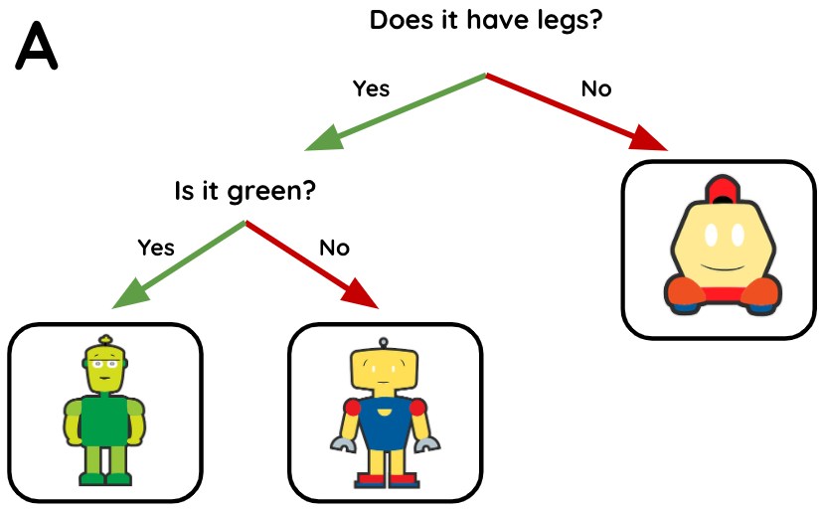 | 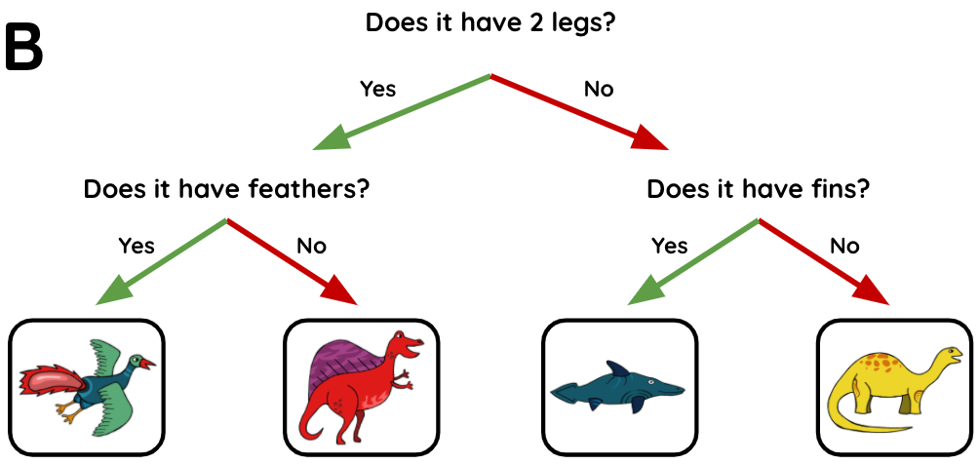
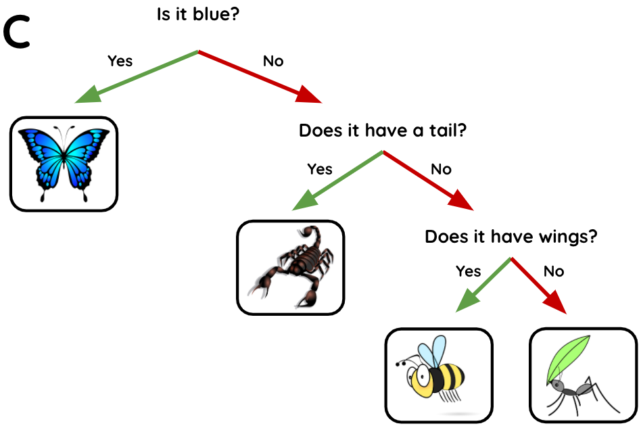 | 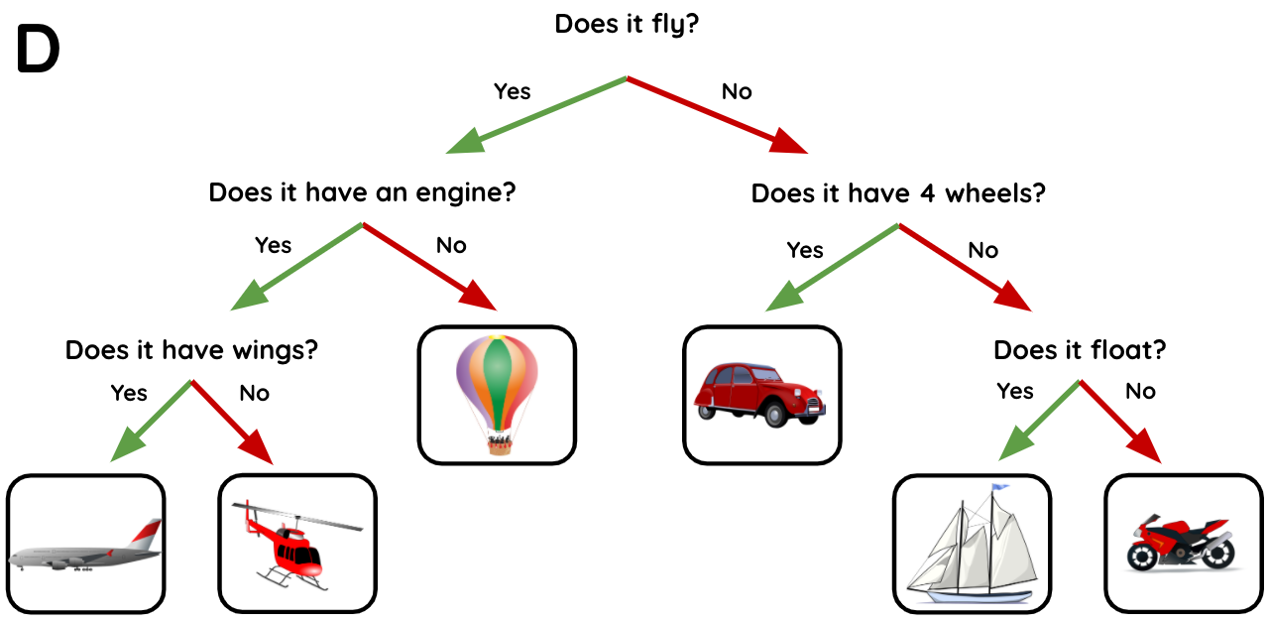

- A
- B
- C
- D

The correct answer is C as it separates the objects one at a time. Answer A only has three objects, so it has to separate one of the objects from the first question as it is not possible to separate them evenly. Answer B and D separate the objects evenly from the initial question.

Image credits:
Sail boat: https://pixabay.com/vectors/sailing-sailboat-transportation-26602/
Container ship: https://pixabay.com/vectors/ship-container-transportation-sea-29771/
Motorbike: https://pixabay.com/vectors/motor-cycle-motorbike-motorcycle-42422/
Red car: https://pixabay.com/vectors/car-vintage-red-old-automobile-33633/
Bicycle: https://pixabay.com/vectors/bicycle-bike-black-rider-1296275/
Hot-air balloon: https://pixabay.com/vectors/hot-air-balloon-balloon-travel-517857/
Helicopter: https://pixabay.com/vectors/helicopter-rotors-flying-vehicle-297742/
Trainers: https://pixabay.com/vectors/athletic-shoes-shoes-sneakers-25493/
Yellow T-shirt: https://pixabay.com/vectors/t-shirt-shirt-clothing-yellow-153370/
Shirt: https://pixabay.com/vectors/clothes-clothing-shirt-1294978/
Jeans: https://pixabay.com/vectors/clothes-clothing-hose-trousers-1294974/
Dinosaurs: https://pixabay.com/vectors/dinosaur-history-prehistoric-4373602/
Blue plane: https://pixabay.com/vectors/aircraft-plane-transportation-158148/
Elephant: https://pixabay.com/illustrations/baby-elephant-elephant-cute-blue-3526681/
Duck: https://pixabay.com/vectors/duck-face-standing-odd-strange-312099/
Sheep: https://pixabay.com/illustrations/lamb-sheep-cute-animal-funny-3539619/
Fish: https://pixabay.com/vectors/fish-tropical-fish-sea-surgeon-1331813/
Red plane: https://pixabay.com/vectors/airbus-airline-airliner-airplane-158485/
Butterfly: https://pixabay.com/vectors/butterfly-blue-insect-summer-wings-2028591/
Scorpion: https://pixabay.com/vectors/scorpion-poisonous-stinger-claws-23158/
Bee: https://pixabay.com/vectors/honeybee-bee-flying-fly-insect-24633/
Ant: https://pixabay.com/vectors/ant-insect-bug-animal-ant-ant-162000/
Robots: https://pixabay.com/vectors/robots-adorable-characters-cute-159598/

Resources are updated regularly — the latest version is available at: ncce.io/tcc.

This resource is licensed under the Open Government Licence, version 3. For more information on this licence, see ncce.io/ogl.

