Summative assessment – Answers

Number bases

Q1. State the number bases for the following types of number:

Number system | Number base
Binary | 2
Decimal | 10
Hexadecimal | 16

Q2. Convert 11110₂ into decimal.

Answer: | 30

Q3. Convert 11111100₂ into hexadecimal.

Answer: | FC

Q4. Convert A2₁₆ into binary.

Answer: | 10100010

Q5. Convert 255₁₀ into binary.

Answer: | 11111111

Q6. Convert 48₁₀ into hexadecimal.

Answer: | 30

Binary addition

Q1. Perform the binary addition for 101010 + 11011.

Answer: | 1000101

Q2. Perform the binary addition for 1010 + 1111.

Answer: | 11001

Q3. Perform the binary addition for 111 + 11 + 10000.

Answer: | 11010

Binary subtraction

Q1. Perform the binary subtraction for 1110 - 1101.

Answer: | 1

Q2. Perform the binary subtraction for 1101 - 1011.

Answer: | 10

Q3. Perform the binary subtraction for 11101 - 1011.

Answer: | 10010

Binary shifting

Q1. What is 1010₂ × 1000₂?

Answer: | 1010000

Q2. What is 111₂ × 10000₂?

Answer: | 1110000

Q3. What is 11011₂ ÷ 10₂?

Answer: | 1101

Q4. What is 11111₂ ÷ 100₂?

Answer: | 111

Sign and magnitude

Q1. Using 8-bit sign and magnitude, convert 11110011₂ into decimal.

Answer: | -115

Q2. Using 8-bit sign and magnitude, convert -68₁₀ into binary.

Answer: | 11000100

Two’s complement

Q1. Using 8-bit two’s complement, convert 00001000₂ into decimal.

Answer: | +8

Q2. Using 8-bit two’s complement, convert 00110000₂ into decimal.

Answer: | +48

Bit patterns

Q1. How many bit patterns can be created with 5 bits?

Answer: | 32

Q2. An image requires the use of 68 colours. How many bits are required to represent 68 bit patterns?

Answer: | 7

Representing text

Q1. A text file that contains 128 characters is created using 8-bit ASCII. How many bytes will the file size be?

Answer: | 128

Q2. A text file that contains 128 characters is created using 16-bit Unicode. How many bytes will the file size be?

Answer: | 256

Q3. Complete this ASCII table by entering the binary values for the missing characters.

Character | Binary value
A | 01000001
B | 01000010
C | 01000011
D | 01000100

Representing images

Q1. If an image has a 3-bit colour depth, how many colours can it have?

Answer: | 8

Q2. An image size is 400 × 400 pixels and the image has a resolution of 100ppi. What is the physical size of the image?

Answer: | 4 inches × 4 inches

Q3. An image is 16 × 16 pixels and has a colour depth of 2. What is the file size in bytes of this image?

Answer: | 64 bytes

Q4. The encoding for this image with a 2-bit colour depth has been started. What is the correct encoding for the third row?

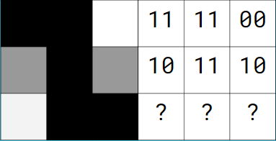

Answer: | 00 11 11

Representing sound

Q1. Which two things have an impact on the quality of a sound representation?

Answer: | Sample rate and sample resolution

Q2. Calculate the file size in bits for a 3-minute sound recording that has used a sample rate of 1,000 hertz and a sample resolution of 2 bits.

Answer: | 360,000 bits

Q3. Calculate the file size in bits for a 2-minute sound recording that has used a sample rate of 1,000 hertz and a sample resolution of 4 bits.

Answer: | 480,000 bits

Measurements of storage

Q1. How many megabytes are in a gigabyte?

Answer: | 1,000

Q2. How many gigabytes are in a terabyte?

Answer: | 1,000

Q3. Place these measurements of storage in order from smallest to largest.

A | 14 bits
B | 1 megabyte
C | 2 bytes
D | 3 nibbles

Write the letters for each measurement in order below:
Answer: | D, A, C, B

Lossy and lossless compression

Q1. True or false? When a lossy compression algorithm is applied, it is impossible to decompress the file back into its original state.

Answer: | True

Q2. True or false? JPEG is a form of lossless compression.

Answer: | False

Q3. True or false? MP3 is a form of lossless compression.

Answer: | False

Run length encoding

Q1. Below is the encoding for a bitmap image. Use run length encoding to compress the image. Use decimal values for the numbers of occurrences.
11 11 00 00 00 00 11 11

Answer: | 2 11 4 00 2 11

Q2. Below is the encoding for a bitmap image. Use run length encoding to compress the image. Use binary values for the numbers of occurrences.
11 11 11 00 00 00 00 11 11

Answer: | 0110 11 1000 00 0010 11

Huffman coding

Q1. Is Huffman coding lossy or lossless compression?

Answer: | Lossless

Q2. This is a Huffman tree that has been created for the word GEMINI. Complete the table below to state the bit pattern that would be used for each character in this word.
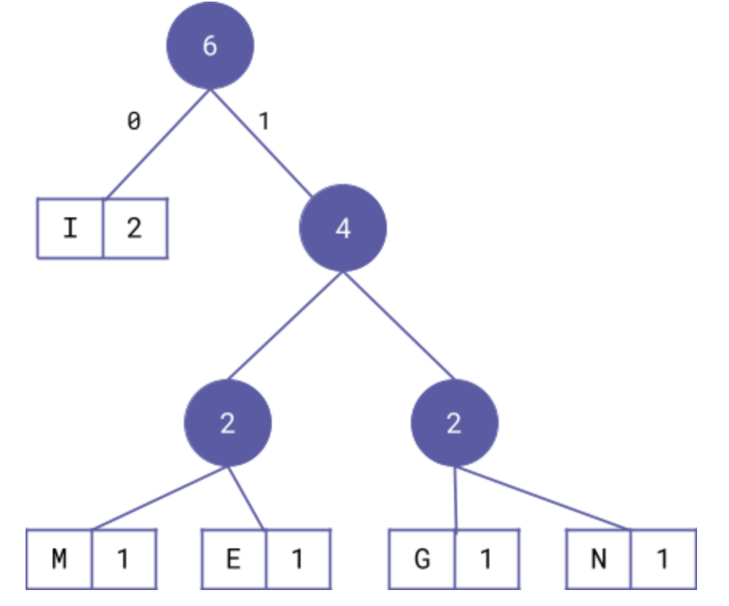

Character | Bit pattern
I | 0
M | 100
E | 101
G | 110
N | 111

Q3. Write down the full bit pattern for the compressed word GEMINI. Use the table above to help you with this.

110 101 100 0 111 0

Q4. What is the file size of the original file containing the word GEMINI in bits if 8-bit ASCII is used?

48 bits

Q5. What is the file size of the compressed file containing the word GEMINI in bits?

14 bits

Q6. How many extra bits are required for the uncompressed file?

34 bits

Resources are updated regularly — the latest version is available at: ncce.io/tcc.

This resource is licensed under the Open Government Licence, version 3. For more information on this licence, see ncce.io/ogl.

