Summative assessment
Q1. A graph is made up of nodes and edges. In the graph below, which label represents a node?

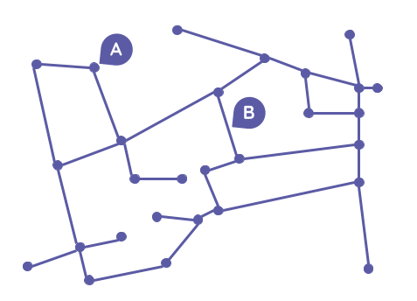

- A
- B

Q2. Which one of the following cannot be described as a network?

- Bus or train routes
- A community of schools, working together
- Staff working in a company
- An employee

Q3. Which one of the following most accurately describes a computer network?

- More than one device, connected together and sharing resources
- Computers connected to each other
- A computer that can be accessed by multiple users

Q4. True or False: In a peer-to-peer network, devices can act as the client and the server.

- True
- False

Q5. Which one of the following is not an advantage of a computer network?

- You can share documents easily
- Users can connect with people in other countries
- Backups can be centralised
- Viruses cannot spread through the connections

Q6. Which one of the statements below correctly describes a ‘client’?

- The client is two or more computers connected together, sharing resources
- The client requests data, information, and actions from the server
- The client responds to requests

Q7. Select three statements that describe the disadvantages of a client–server network.

- They are expensive to set up
- If a client machine breaks, it will affect the whole network
- If the server fails, then everyone connected to that server is disrupted
- A specialist network administrator is required to set up the network

Q8. Networks can operate in three areas: personal, local, or wide. Select the correct description of a local area network.

- Typically limited to a single user. This might be a user with a smart watch, a phone, and a laptop sharing data.
- Typically limited to a single location. This might be multiple devices connected together and sharing resources.
- Typically over a large geographical area (including globally). This could be billions of devices connected together and sharing resources.

Q9. Which networking device broadcasts data to all wired devices attached to it?

- Router
- Hub
- NIC
- Bridge

Q10. Which networking device links one local area network (LAN) to another LAN?

- Router
- Hub
- NIC
- Bridge

Q11. Which networking device is essential for connecting a device to the internet?

- Router
- Hub
- NIC
- Bridge

Q12. Which network topology does the graph below represent?

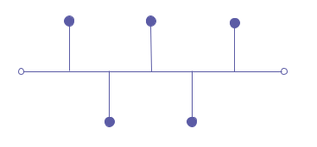
- Star
- Bus
- Ring
- Mesh

Q13. Which network topology does the graph below represent?

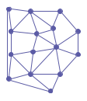

- Star
- Bus
- Ring
- Mesh

Q14. Which one of the following is an advantage of a mesh topology?

- It is the cheapest topology to set up
- It doesn’t require specialist knowledge to set up
- There is no central node, so there is no single point of failure
- There is less chance for data collision because the data moves in one direction, this makes data transmission quite fast

Q15. Which one of the following is not a type of transmission media?

- Network interface card (NIC)
- Copper cable
- Fibre optics
- Radio signals (used for WiFi and Bluetooth)

Q16. Which one of the following is a feature of fibre optic cable?

- It uses electrical signals to transmit data
- It uses light pulses to transmit data
- It uses radio frequencies to transmit data

Q17. Which type of transmission media has the largest range?

- Radio frequencies used with WiFi
- Radio frequencies used with Bluetooth

Q18. Which one of the following is an advantage of wired transmission media?

- Multiple users can access the network with minimal configuration (typically a password)
- It’s cheaper to expand the network and add more devices compared to other transmission media types
- There is increased mobility for users because devices can move around and stay connected to the network.
- Connections are typically more stable compared to other transmission media types

Q19. Which one of these statements is a description of latency?

- It is a measure of how much data can be transferred in a specific amount of time
- It is the maximum distance that data can travel through transmission media
- It is the delay from the time a signal is sent to when it is received

Q20. What is the lowest possible routing cost from A to B across this network?

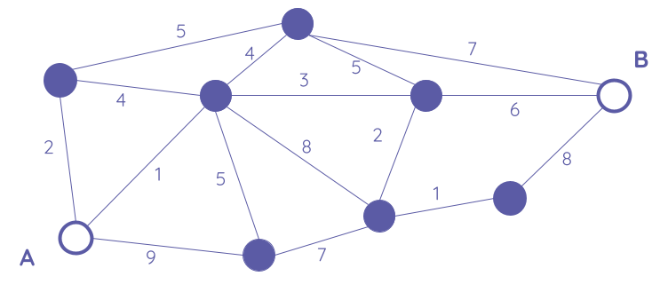

Answer:

Q21. How many seconds will it take to transmit 20,000 bits of data using a network transmission speed of 1,000 bits per second?

Answer:

Q31. Which one of the following enables a device to be located on the internet?

- IP address
- Search engine
- Web browser

Q32. Which one of the following most accurately describes a domain name system (DNS)?

- It is a collection of servers that lists all of the websites that exist
- It is a collection of servers that lists all of the devices that are connected to the internet
- It is a collection of servers that lists commonly used website addresses and their IP addresses

Q33. Which one of the following is not an advantage of cloud services?

- Automatic saving
- Automatic backups
- Accessible from anywhere with an internet connection
- Advanced control of where personal data is located

Q34. What is the term used to describe a set of rules used for communication?

Answer:

Q35. Which one of the following protocols is used to securely identify, request, and transfer web pages across the internet?

- HTTP
- HTTPS
- Ethernet
- WiFi

Q36. POP, IMAP, and SMTP are all email protocols. Which one deals with the sending of emails?

- POP
- IMAP
- SMTP

Q37. There are four layers of the TCP/IP model. Three of these layers are link, internet, and transport. Which one is missing?

Answer:

Q38. Which one of the following describes the role of the internet layer?

- This layer deals with the IP protocol. It uses this to create IP packets from the data passed into it from the above layer. The IP packet has a header that lists the sender and receiver’s IP addresses.
- This layer deals with the physical transmission of the data. It creates frames from the IP packets passed to it from the above layer. These frames include a header that lists the protocol used for the technology that is used from the current node to the next node on the network. It also lists the destination MAC address.
- This layer checks if the data needs to be broken down into segments. If so, it performs this operation. Once the data has been divided into segments, a header is added with information about the protocol used (either TCP or UDP) and the sender and receiver’s port numbers.

Q39. Which one of the following describes the role of the transport layer?

- This layer deals with the IP protocol. It uses this to create IP packets from the data passed into it from the above layer. The IP packet has a header that lists the sender and receiver’s IP addresses.
- This layer deals with the physical transmission of the data. It creates frames from the IP packets passed to it from the above layer. These frames include a header that lists the protocol used for the technology that is used from the current node to the next node on the network. It also lists the destination MAC address.
- This layer checks if the data needs to be broken down into segments. If so, it performs this operation. Once the data has been divided into segments, a header is added with information about the protocol used (either TCP or UDP) and the sender and receiver’s port numbers.

Q40. Which one of the protocols listed below operates in the link layer?

- HTTP
- TCP
- IP
- Ethernet

Q41. Which one of the protocols listed below operates in the transport layer?

- HTTP
- TCP
- IP
- Ethernet

Q42. Which layer does the SMTP protocol operate in?

Answer:

Q43. Which one of the following describes the term ‘blagging’?

- This is when an attacker invents a scenario in order to convince the victim to give them data or money. This attack often requires the attacker to maintain a conversation with the victim until they are persuaded to give up whatever the attacker has asked for.
- This is an attack designed to steal a victim's password, or other sensitive data. It involves the attacker watching the victim provide sensitive information.
- This is when an attacker sends fraudulent emails to large groups of people in an attempt to get them to click a link to a site that encourages them to enter their personal details.

Q44. Which one of the following describes the term ‘phishing’?

- This is when an attacker invents a scenario in order to convince the victim to give them data or money. This attack often requires the attacker to maintain a conversation with the victim until they are persuaded to give up whatever the attacker has asked for.
- This is an attack designed to steal a victim's password, or other sensitive data. It involves the attacker watching the victim provide sensitive information.
- This is when an attacker sends fraudulent emails to large groups of people in an attempt to get them to click a link to a site that encourages them to enter their personal details.

Resources are updated regularly — the latest version is available at: ncce.io/tcc.

This resource is licensed under the Open Government Licence, version 3. For more information on this licence, see ncce.io/ogl.

