Summative assessment – Questions

Variables in games

Q1. Which of these are important features of a variable? Tick all that apply.

- Can be set
- Is a score
- Can be changed
- Has a clear name

Q2. Which data types can a variable hold?

- Numbers only
- Letters only
- Numbers or letters
- Pictures

Q3. How many values can a variable hold at any one time?

- None
- One
- Two
- Three

Q4. When a variable is changed, what happens to the value?

- It is replaced by a new value
- It is joined by the new value
- It is added to the new value

Q5. In a bat and ball game, which of these parts of the game would be stored using a variable? Tick all that apply.

- Points scored
- Movement of the sprite
- Lives lost
- Time left
- Appearance of the Stage

Q6. Imagine that you are storing the score of a football match using a computer program to display to the crowd during the game. Which name would be the best choice for the variable that holds the score of the home team?

- Home score
- Home_score
- Football_match_home_team_score
- Score

Q7. Where is the value of a variable usually set?

- At the beginning of a program
- Throughout the running of a program
- At the end of a program
- When triggered by an event

Q8. Which of the following code snippets would create a timer that counts down from 60 seconds to 0?

A. | B.
C. | D.

Q9. The code snippet below controls the movement of a ball in a game in the style of table tennis. The Stage is also shown next to the code.

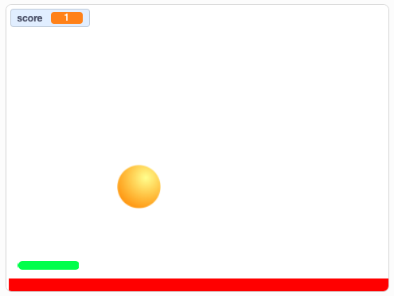

When will the score change?

- When the ball moves
- When the ball touches the paddle
- When the green flag is clicked
- When the ball hits the edge

Q10. What describes the order in which commands are run during a program?

- The algorithm
- The code
- The program flow
- The task

Resources are updated regularly — please check that you are using the latest version.

This resource is licensed under the Open Government Licence, version 3. For more information on this licence, see ncce.io/ogl.

