Summative assessment

Branching databases
Q1. Which of these questions could be used in a branching database?

- What is your favourite colour?
- How many dinosaurs are there?
- Is it bigger than a tennis ball?
- What is the first day of the week?

Q2. Which question(s) could be used to separate these shapes into two groups? Tick all that apply.

- Is it black?
- Is it a circle?
- Is it a shape?
- Is it big?

Q3. Which of the shapes does not share a common attribute with any of the others?

- The black circle
- The white square
- The grey circle
- The black triangle

Q4. What would be the best question to separate this set of objects?

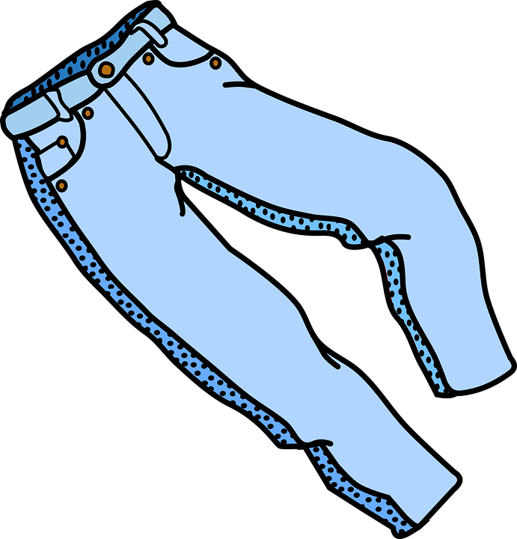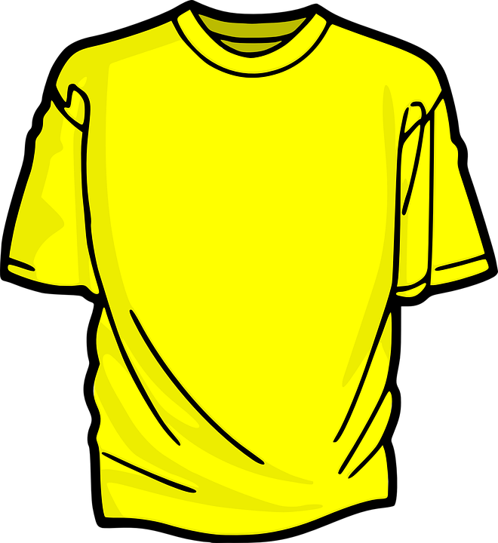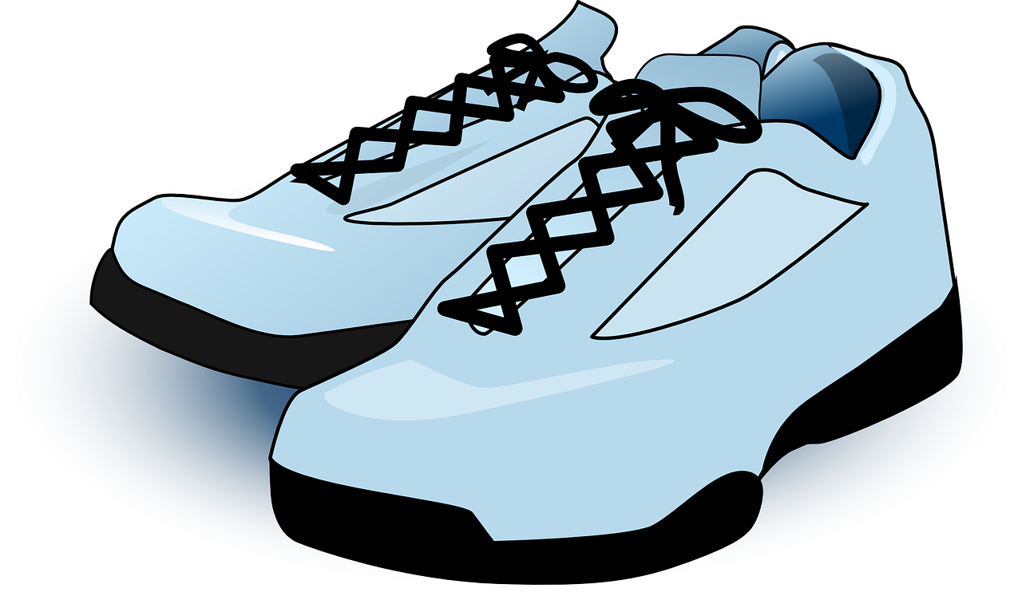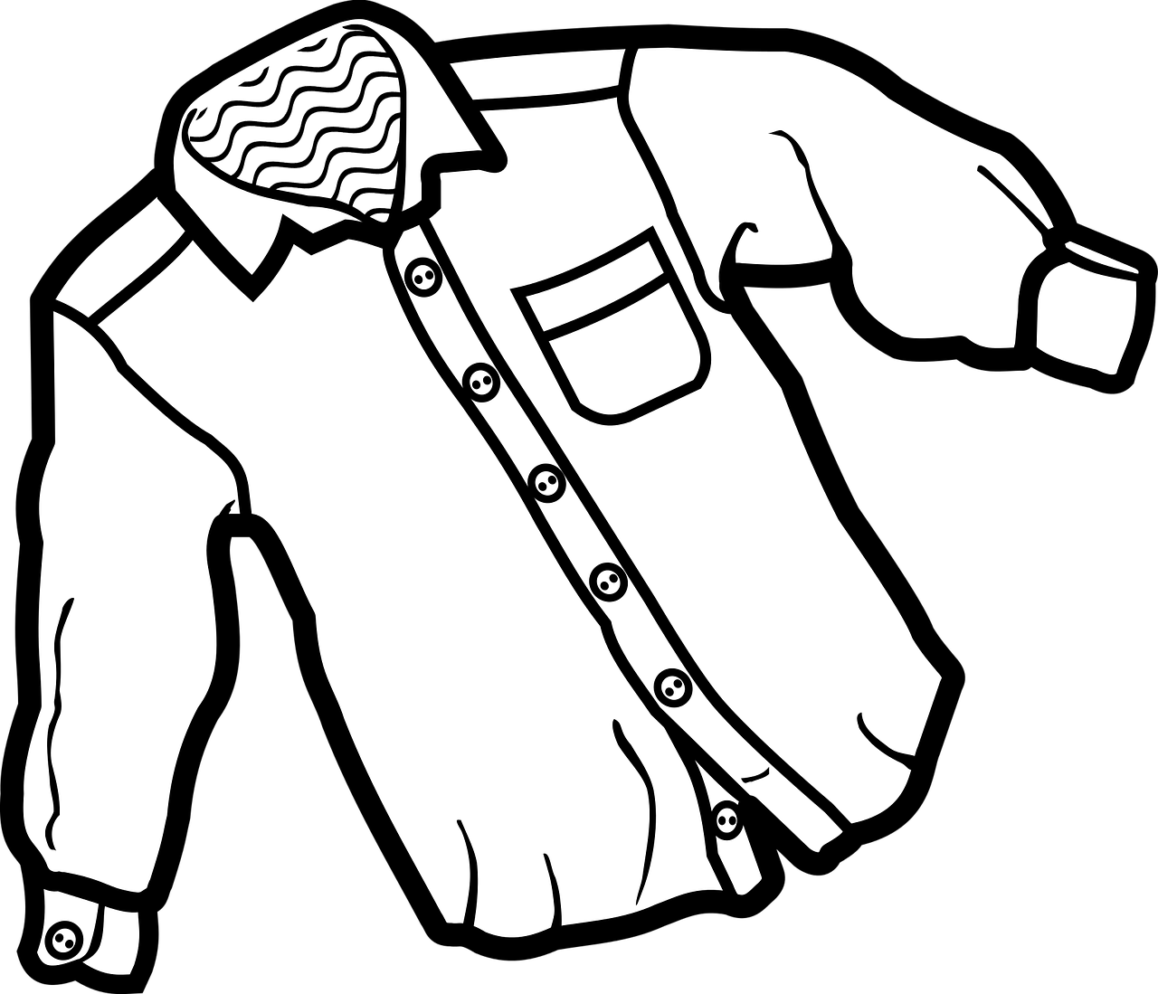

- Does it have a button?
- Does it have long sleeves?
- Does it have more than one pocket?
- Does it have laces?

Q5. What attribute(s) do these objects not have? Tick all that apply.

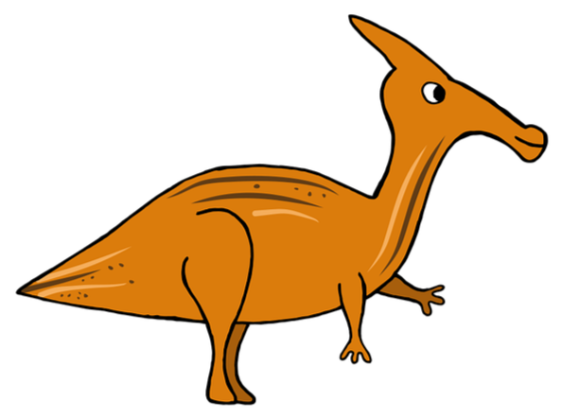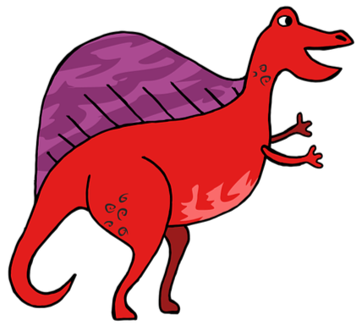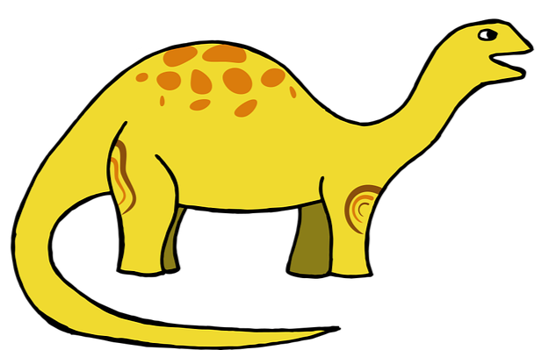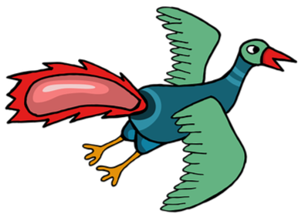

- Legs
- Wings
- Wheels
- Back fin
- Stripes

Q6. Where would these objects be placed in the branching database?

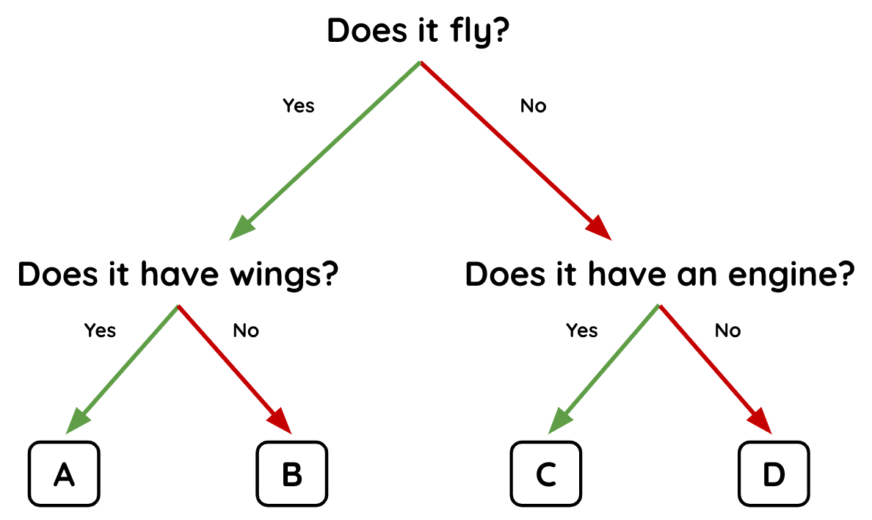

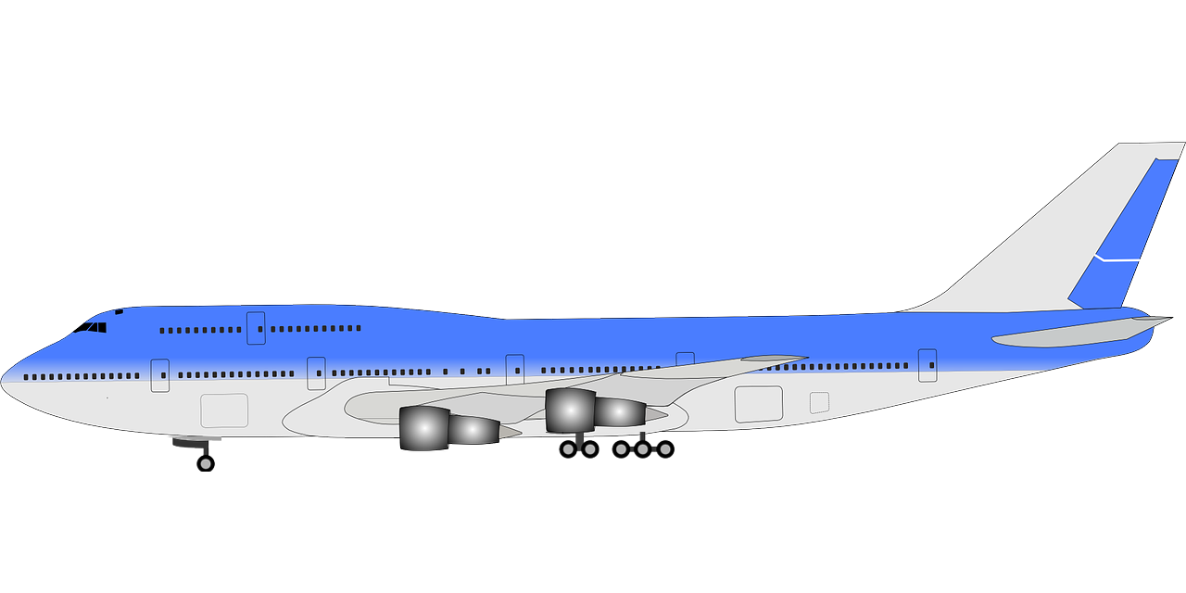 | - A  - B  - C  - D
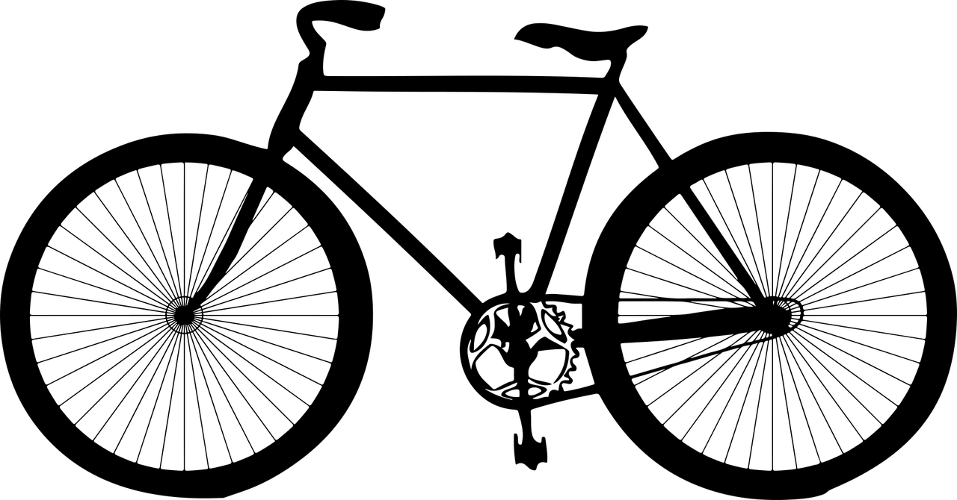 | - A  - B  - C  - D

Q7. Circle 3 mistakes in this branching database.

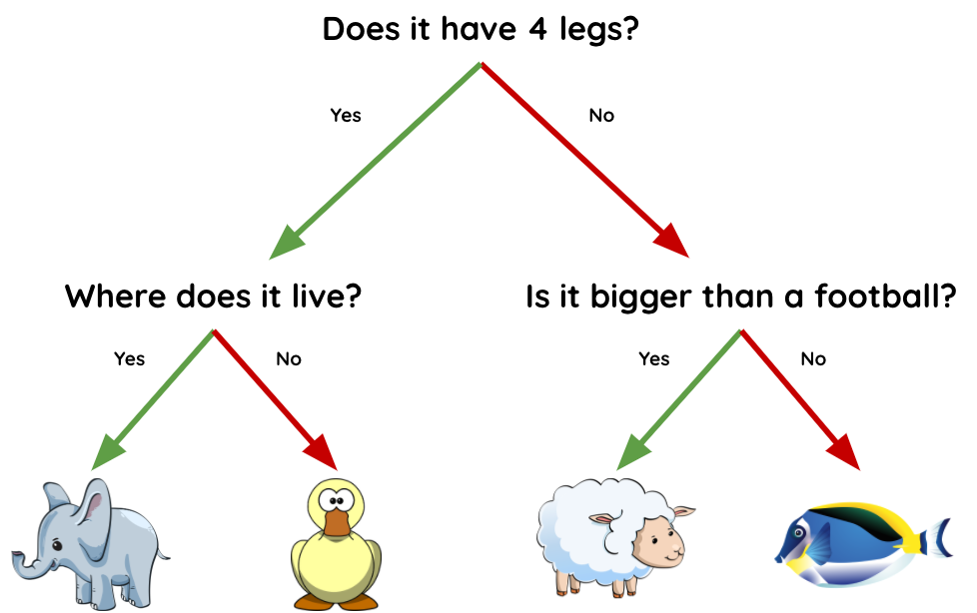

Q8. Which of these best describes the structure of a branching database?

- Graph
- Tree
- Branch
- Table
- List

Q9. Where does the question “Does it float?” fit into this branching database?

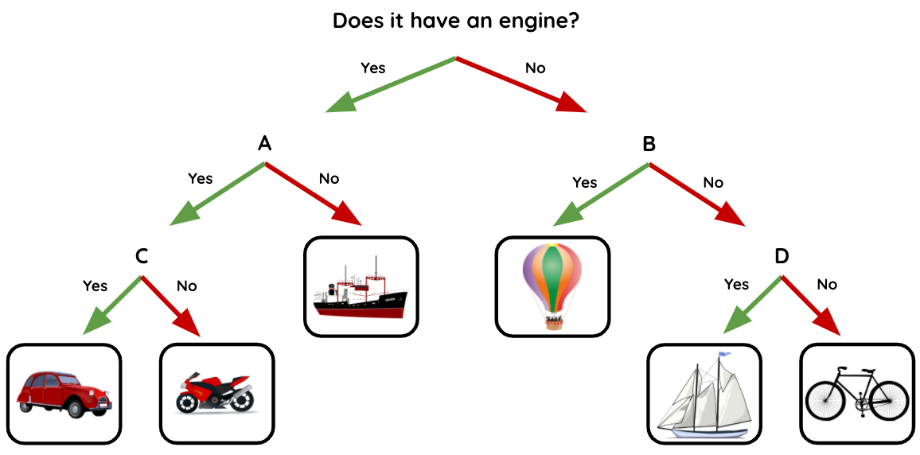

- A
- B
- C
- D

Q10. Which branching database is least well structured?

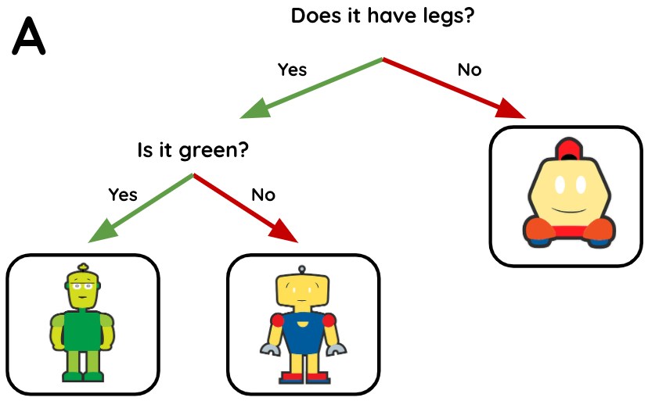 | 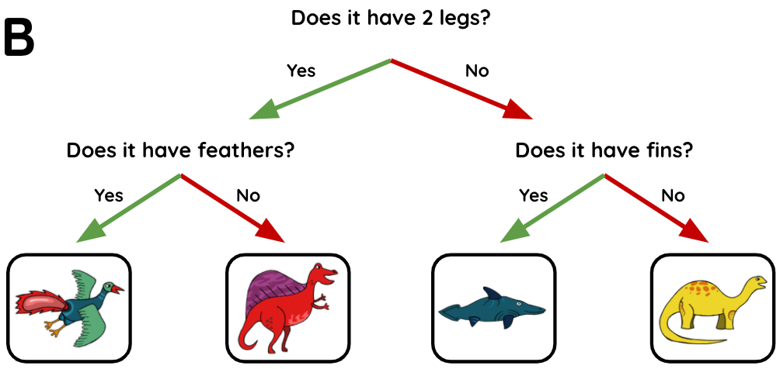
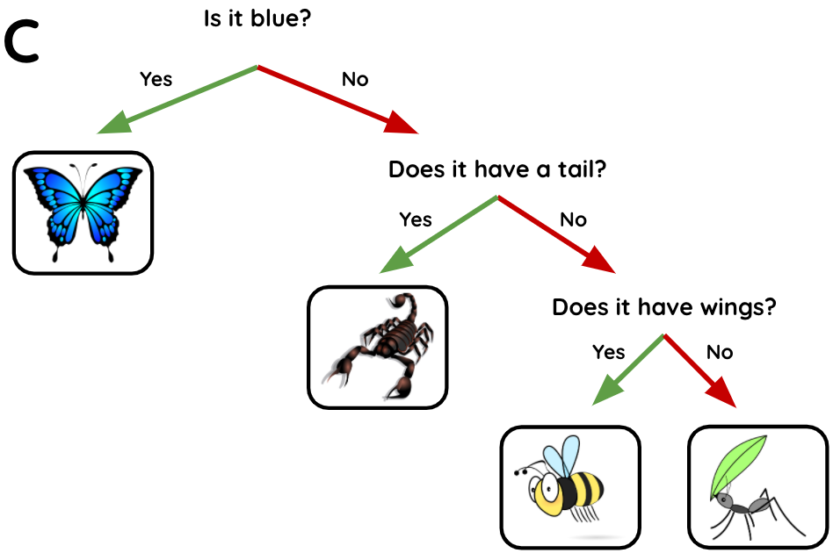 | 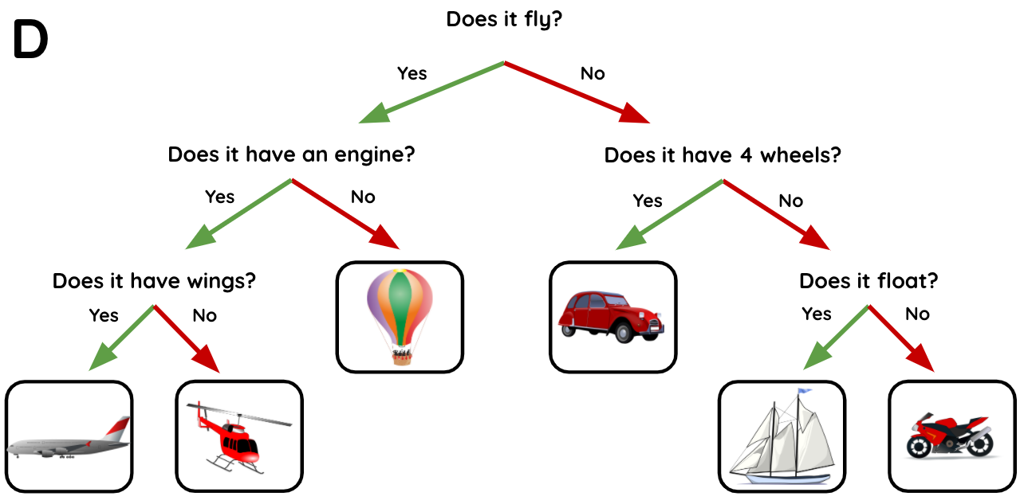

- A
- B
- C
- D

Image credits:
Sail boat: https://pixabay.com/vectors/sailing-sailboat-transportation-26602/
Container ship: https://pixabay.com/vectors/ship-container-transportation-sea-29771/
Motorbike: https://pixabay.com/vectors/motor-cycle-motorbike-motorcycle-42422/
Red car: https://pixabay.com/vectors/car-vintage-red-old-automobile-33633/
Bicycle: https://pixabay.com/vectors/bicycle-bike-black-rider-1296275/
Hot-air balloon: https://pixabay.com/vectors/hot-air-balloon-balloon-travel-517857/
Helicopter: https://pixabay.com/vectors/helicopter-rotors-flying-vehicle-297742/
Trainers: https://pixabay.com/vectors/athletic-shoes-shoes-sneakers-25493/
Yellow T-shirt: https://pixabay.com/vectors/t-shirt-shirt-clothing-yellow-153370/
Shirt: https://pixabay.com/vectors/clothes-clothing-shirt-1294978/
Jeans: https://pixabay.com/vectors/clothes-clothing-hose-trousers-1294974/
Dinosaurs: https://pixabay.com/vectors/dinosaur-history-prehistoric-4373602/
Blue plane: https://pixabay.com/vectors/aircraft-plane-transportation-158148/
Elephant: https://pixabay.com/illustrations/baby-elephant-elephant-cute-blue-3526681/
Duck: https://pixabay.com/vectors/duck-face-standing-odd-strange-312099/
Sheep: https://pixabay.com/illustrations/lamb-sheep-cute-animal-funny-3539619/
Fish: https://pixabay.com/vectors/fish-tropical-fish-sea-surgeon-1331813/
Red plane: https://pixabay.com/vectors/airbus-airline-airliner-airplane-158485/
Butterfly: https://pixabay.com/vectors/butterfly-blue-insect-summer-wings-2028591/
Scorpion: https://pixabay.com/vectors/scorpion-poisonous-stinger-claws-23158/
Bee: https://pixabay.com/vectors/honeybee-bee-flying-fly-insect-24633/
Ant: https://pixabay.com/vectors/ant-insect-bug-animal-ant-ant-162000/
Robots: https://pixabay.com/vectors/robots-adorable-characters-cute-159598/

Resources are updated regularly — the latest version is available at: ncce.io/tcc.

This resource is licensed under the Open Government Licence, version 3. For more information on this licence, see ncce.io/ogl.

