Summative assessment – Answers

Using databases

Q1. Computer databases allow us to organise, __________, and sort data.

- measure
- search
- field

B is correct, showing that learners understand that a computer database allows data to be searched. Answer A suggests that learners do not understand that a flat-file database contains a dataset which can be searched, sorted, and graphed. Answer C suggests learners have recognised a term related to databases but misunderstood what it means.

Q2. Which of these are examples of database fields? (tick all that apply)

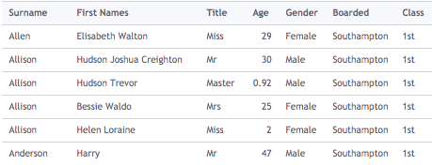
- 1st
- Age ✔
- Mr
- Class ✔

The correct answers are B and D. We know this, as they are the fields in ‘record view’ which are presented as headings in the ‘table view’. The wrong answers show confusion over the difference between the data in the field and the field itself.

Q3. How many records can you see in this database?

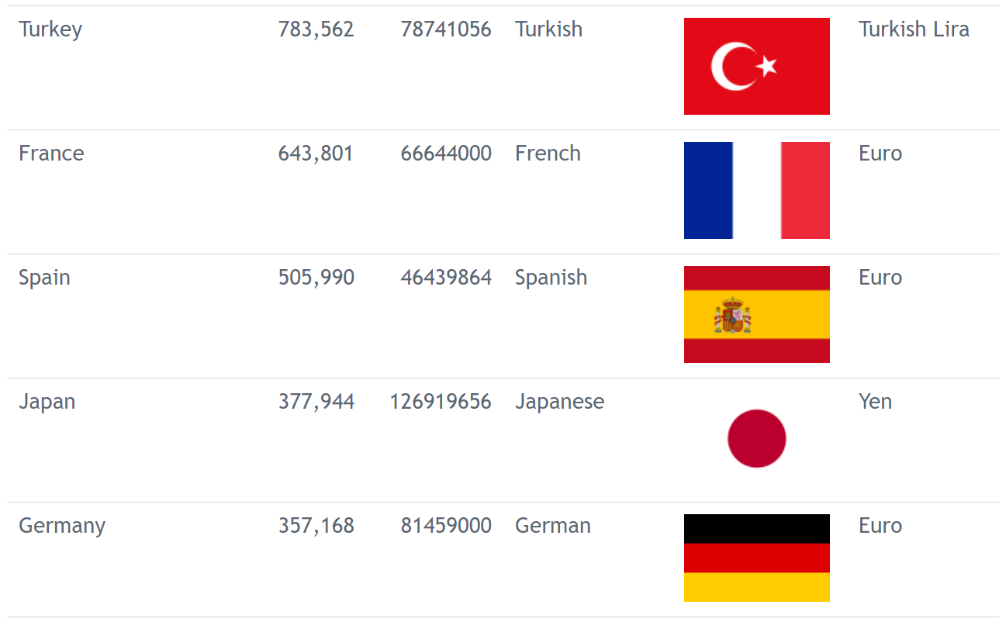

- 6
- 30
- 5 ✔
- 15

The correct answer is C. There are records for Turkey, France, Spain, Japan, and Germany. If they have answered A, they are unsure on the difference between ‘records’ and ‘fields’. If they have answered B, they are counting the individual data items, not those that are grouped into records.

Q4. Here is the table view of a database. We want to answer the question: ‘How long is the longest dinosaur?’ Which field would you use to answer it?

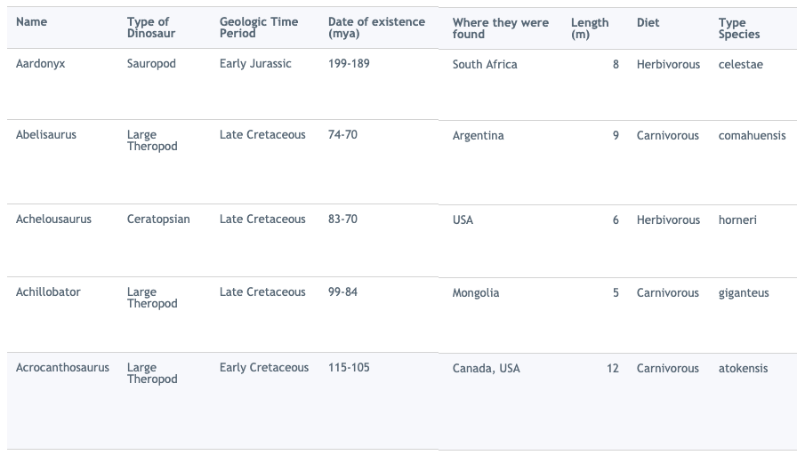

- Name
- Diet
- Length ✔
- 12

The correct answer is C. Choosing answers A and B indicates misconceptions around how the data is organised in the database. Answer D shows the answer to the question, but not which field was used to find it. To know that 12 is the answer, the whole field must first be reviewed.

Q5. Which field has this data been sorted by?
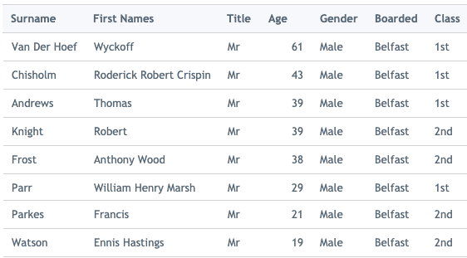

- Surname
- Class
- Boarded
- Age ✔

The correct answer is D. The other fields which we can see contain mostly the same information, and therefore sorting them would not make any difference.

Q6. What would you search for to answer this question: ‘How many males under ten years old were on board the Titanic?’

- Name and age
- Gender and class
- Gender or age
- Gender and age ✔

The correct answer is D. Choosing A or B indicates a lack of understanding of which fields are needed in this search, and choosing C indicates a lack of understanding about the difference between ‘AND’ and ‘OR’ searches. ‘Or’ would return just the men with an age under ten whereas ‘And’ would return all male passengers and all those under the age of ten.

Q7. The Titanic picked up passengers from:
- Southampton
- Cherbourg
- Queenstown
- Belfast

What would you search for to answer this question: ‘Altogether, how many people boarded at the highlighted places?’

- Age = 10 and Boarded = Belfast
- Boarded = Belfast or Boarded = Queenstown ✔
- Boarded = Queenstown or Age = 10
- Boarded = Queenstown and Boarded = Belfast

The correct answer is B. Choosing A or C indicates a misconception of what information is needed to answer the question, and choosing D indicates a lack of understanding about the difference between ‘AND’ and ‘OR’ searches. ‘Or’ would return those people who boarded in each of those places, whereas ‘And’ would return nothing, as no people boarded the Titanic in both Belfast and Queenstown.

Q8. Which two fields have been used to create this graph?
- Population and country name
- Country name and area ✔
- Area and currency
- Currency and population

The correct answer is B. Choosing any other answer indicates that learners do not have a secure knowledge of how fields can be used to create graphs.

Q9. Here are two views which you can see when using a database: ‘table view’ and ‘chart view’. If I wanted to know which two of the countries listed had the largest population, which view would be the most useful?

A.
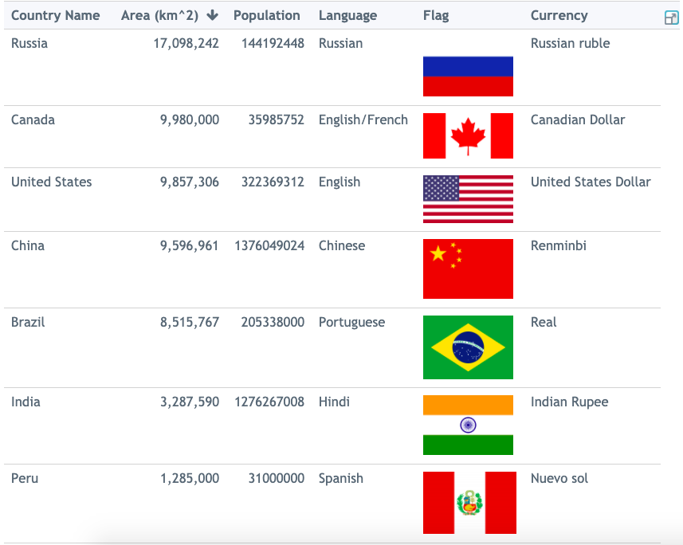
B.
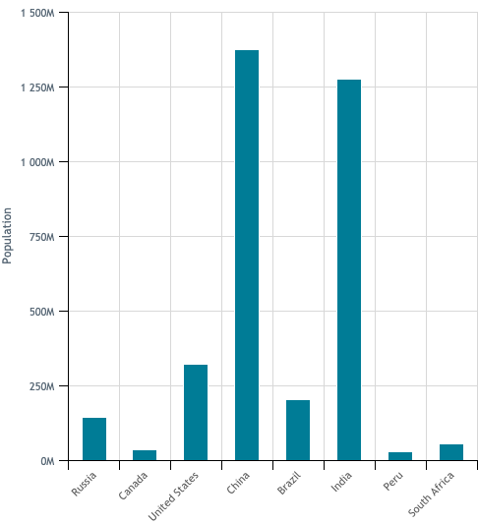

The correct answer is B, as at a quick glance you can see how much taller the bars are for China and India than the other countries listed. Choosing A means that learners are not confident at retrieving information from different views of the database.

Q10. This is a website for a shop called Thames Online. This website uses a database to store the information it needs. Circle three fields that you can see in this image.

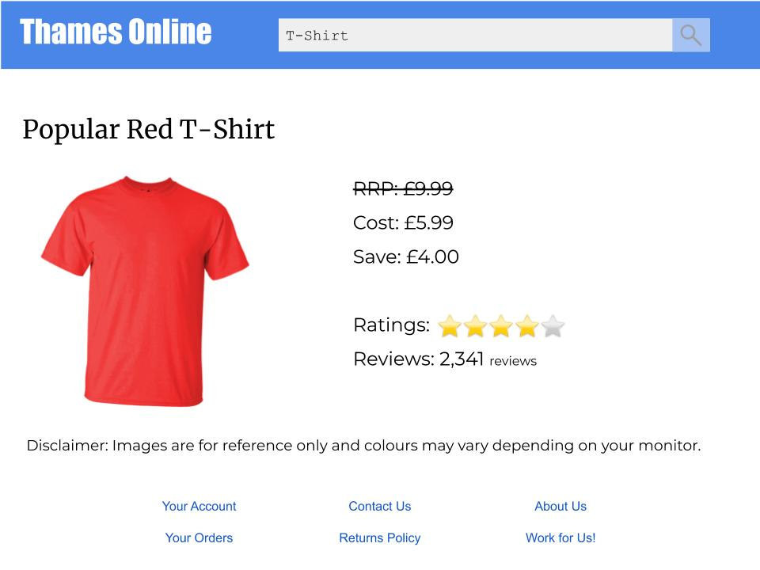

This activity shows whether learners can see how databases are used in a business. They need to recognise which fields would be important and useful for a shop to record.

Resources are updated regularly — the latest version is available at: ncce.io/tcc.

This resource is licensed under the Open Government Licence, version 3. For more information on this licence, see ncce.io/ogl.

Screenshots of databases are all from https://www.j2e.com/data/examples
Images for Thames online:
https://pixabay.com/photos/blank-tshirt-male-fashion-top-1886008/
https://pixabay.com/vectors/magnifying-glass-search-search-bar-1976105/
https://pixabay.com/vectors/star-heart-vector-icon-glossy-2717442/

