Summative assessment answers

Year 9 – Data Science
1. Which of the following is the most accurate definition of data science?
  - Data science is extracting meaning from large data sets in order to provide insights to support decision-making
  - Data science is using computers to analyse data and to perform calculations on the data to produce information
  - Data science is performing experiments and recording the data produced by those experiments
  - Data science is writing code to make sure that any inaccuracies in data sets are spotted and removed (cleaned)

2. Which of the following best describes a data visualisation?

A. Presenting related data so that a user can see individual items of data
B. Making sure that data is accessible and that no data is hidden
C. A visual representation that communicates relationships among the data
D. A collection of graphs that tell a story when put together

3. Is the following a visualisation or an infographic?

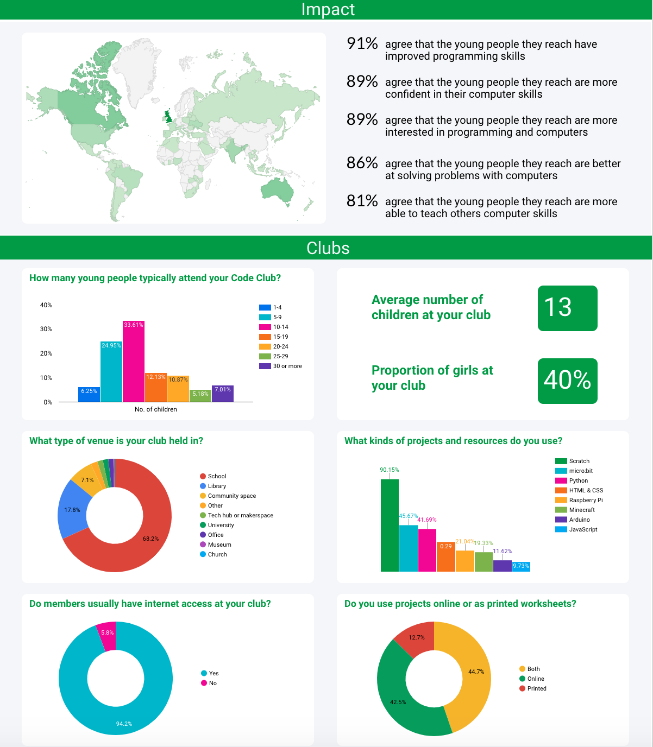

A. Visualisation
B. Infographic

4. What is meant by a correlation?

A. The relationship between two or more variables
B. When there is an upward trend in a graph
C. When there is a set of data that doesn’t lie in the normal or expected range
D. When data is placed in a graph

5. The visualisation below plots life expectancy (y-axis) against time (x-axis). What type of correlation does this visualisation show from 1949 onwards?

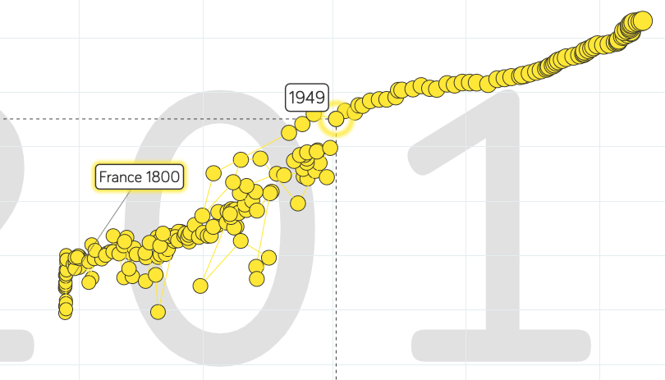

A. Positive
B. Negative
C. Neutral
D. No correlation is visible

6. The following graph shows the annual average temperatures recorded by a weather station over a period of 20 years. Identify the outlier in the data.

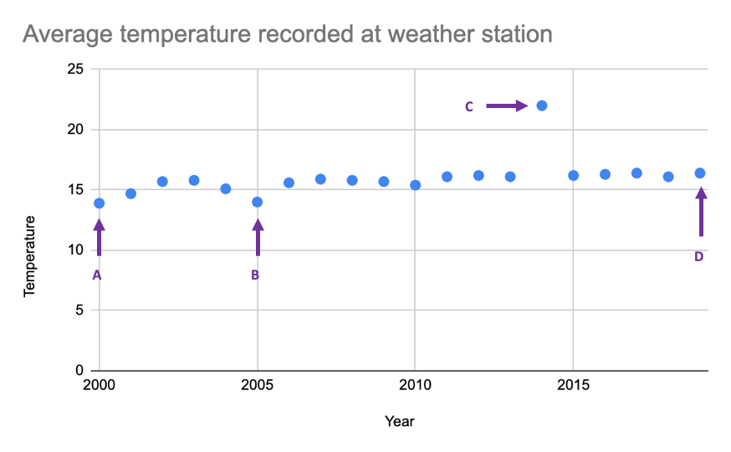
A. Point A
B. Point B
C. Point C
D. Point D

7. Which of the following is the correct order of the investigative cycle?

A. Problem, data, plan, analysis, conclusion
B. Conclusion, plan, problem, data, Analysis
C. Plan, problem, analysis, data, conclusion
D. Problem, plan, data, analysis, conclusion

8. In which step of the cycle would you pose the question(s) that you will use data to help you answer?

A. Data
B. Analysis
C. Plan
D. Problem

9. In which step of the cycle would you cleanse the data?

A. Data
B. Analysis
C. Plan
D. Problem

10. In which step of the cycle would you work out where the data will come from or how you will collect it?

A. Data
B. Analysis
C. Plan
D. Problem

Resources are updated regularly — the latest version is available at: ncce.io/tcc.

This resource is licensed under the Open Government Licence, version 3. For more information on this licence, see ncce.io/ogl.

