Summative assessment – Questions

Using databases

Q1. Computer databases allow us to organise, __________, and sort data.

- measure
- search
- field

Q2. Which of these are examples of database fields? (tick all that apply)

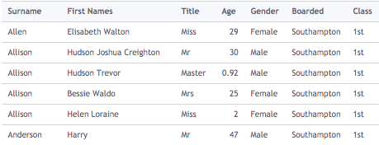

- 1st
- Age
- Mr
- Class

Q3. How many records can you see in this database?

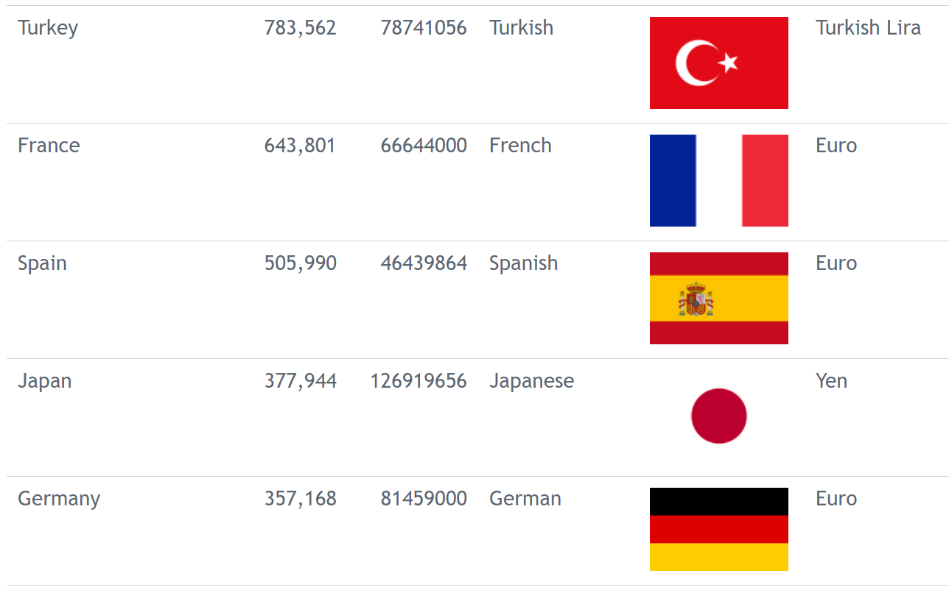

- 6
- 30
- 5
- 15

Q4. Here is the table view of a database. We want to answer the question: ‘How long is the longest dinosaur?’ Which field would you use to answer it?

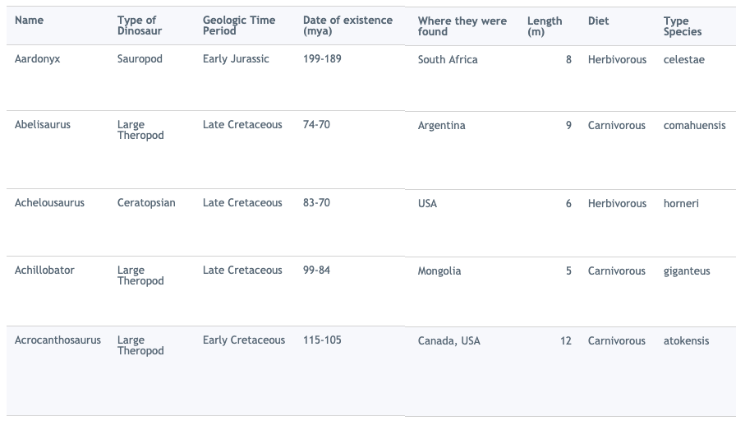

- Name
- Diet
- Length
- 12

Q5. Which field has this data been sorted by?

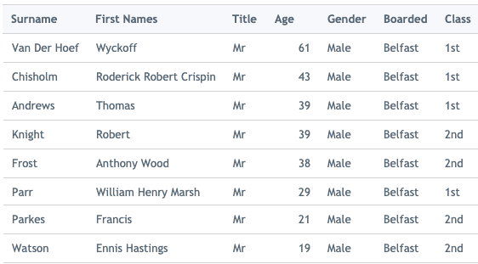

- Surname
- Class
- Boarded
- Age

Q6. What would you search for to answer this question: ‘How many males under ten years old were on board the Titanic?’

- Name and age
- Gender and class
- Gender or age
- Gender and age

Q7. The Titanic picked up passengers from:
- Southampton
- Cherbourg
- Queenstown
- Belfast

What would you search for to answer this question: ‘Altogether, how many people boarded at the highlighted places?’

- Age = 10 and Boarded = Belfast
- Boarded = Belfast or Boarded = Queenstown
- Boarded = Queenstown or Age = 10
- Boarded = Queenstown and Boarded = Belfast

Q8. Which two fields have been used to create this graph?
- Population and country name
- Country name and area
- Area and currency
- Currency and population

Q9. Here are two views which you can see when using a database: ‘table view’ and ‘chart view’. If I wanted to know which two of the countries listed had the largest population, which view would be the most useful? __

A.
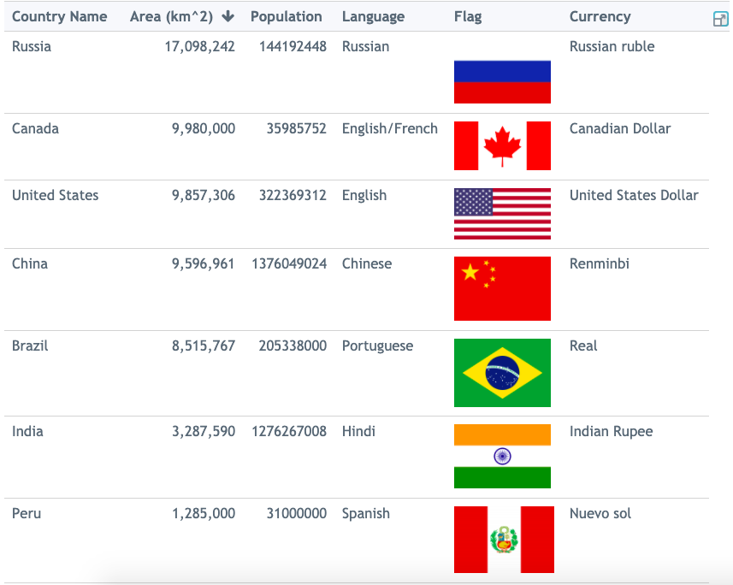
B.
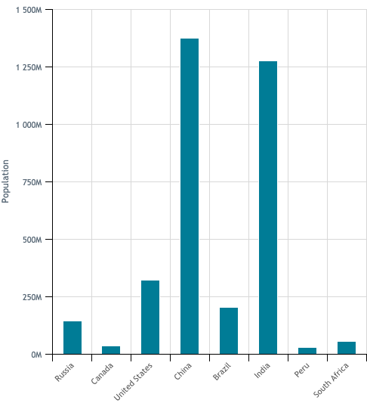
Q10. This is a website for a shop called Thames Online. This website uses a database to store the information it needs. Circle three fields that you can see in this image.

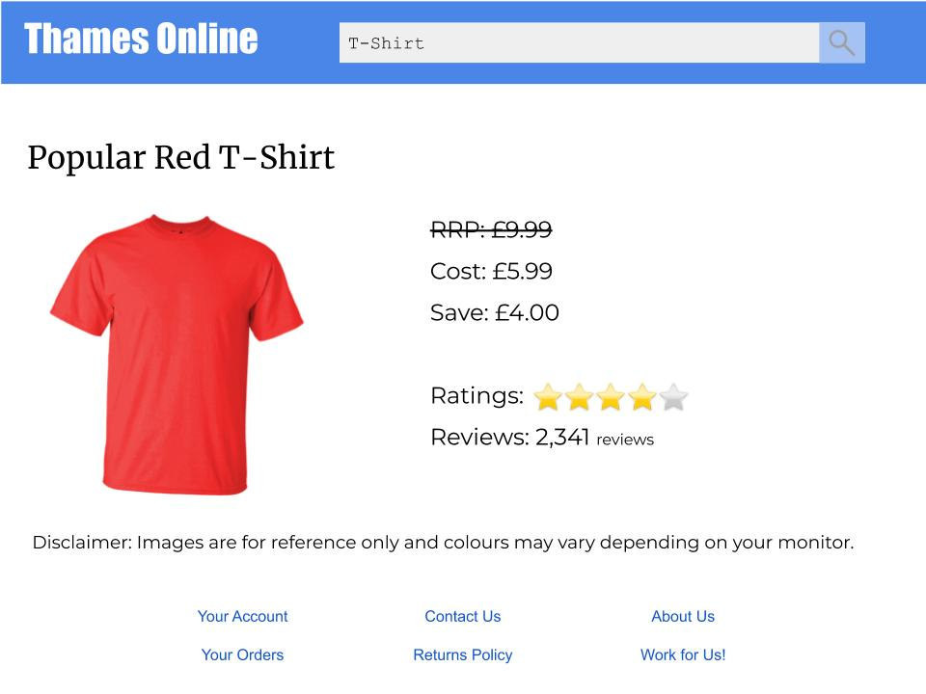

Resources are updated regularly — the latest version is available at: ncce.io/tcc.

This resource is licensed under the Open Government Licence, version 3. For more information on this licence, see ncce.io/ogl.

Screenshots of databases are all from https://www.j2e.com/data/examples
Images for Thames online:
https://pixabay.com/photos/blank-tshirt-male-fashion-top-1886008/
https://pixabay.com/vectors/magnifying-glass-search-search-bar-1976105/
https://pixabay.com/vectors/star-heart-vector-icon-glossy-2717442/

