Summative assessment: Answers
Q1. The internet is...

- Part of a network
- A global network of networks ✔
- The wires which connect computers together
- Another word for the World Wide Web

The correct answer is B. Answer A may indicate that the learner does not have a secure understanding that the internet is many networks joined together. Answer C indicates a narrow view of the internet and answer D demonstrates the common misconception that the internet and the World Wide Web are the same thing. They are not — the World Wide Web is part of the internet.

Q2. The purpose of routers is to (tick all that apply):

- Connect networks together ✔
- To send information around the internet ✔
- Choose the quickest route for information ✔
- Keep networks safe
- Store websites

The first three answers are correct. The first option shows an understanding that many networks are joined together to form larger networks, the second answer underlines the purpose of routers to direct information and the third point acknowledges that routers make decisions, based on a number of factors, to route information as quickly and efficiently as possible. The last two answers demonstrate that learners do not have a secure knowledge of network infrastructure.

Q3. What is the quickest route to C (fewest steps)?

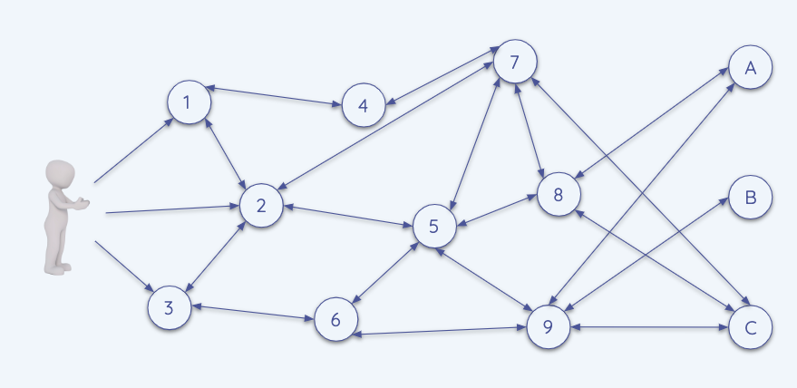

The fastest route is via nodes 2 and 7.

Q4. Fill in the blanks using the words below:

The internet is connected by lots of _______. The ____________ is part of the _______ where we can visit ________ and ________.

World Wide Web websites internet routers web pages

The internet is connected by lots of routers. The World Wide Web is part of the internet where we can visit websites and web pages.

Q5. Which of these can be shared via the World Wide Web? (tick all that apply)

- Touch
- Taste
- Sounds ✔
- Smell
- Sights ✔

The correct answers are sounds and sights. Any other responses may indicate a lack of understanding of the senses, or a limited knowledge of what content online can look like.

Q6. Match these domains and websites:

.gov A school or college

.sch.uk A company

.fr A government website

.com A website from France

.gov -> a government website
.sch.uk -> a school or college
.fr -> a website from France
.com -> a company

Q7. Which of these are web browsers? (tick all that apply)

- Chrome ✔
- Google.co.uk
- Windows
- Firefox ✔
- Edge ✔

Chrome, Firefox, and Edge are browsers. If Google is selected, this demonstrates a common misconception that the World Wide Web is accessed via Google. A further complication is that Chrome is a Google product and is a browser. If Windows is selected, this shows that the learner cannot differentiate between an operating system and a browser.

Q8. Which of these websites lets you create your own content? (tick all that apply)

- Scratch ✔
- BBC Newsround
- Chrome Music Lab ✔
- YouTube ✔

Scratch, Chrome Music Lab and YouTube enable you to create content. BBC Newsround only lets you view or listen to content.

Q9. Who owns video content on YouTube? The person who...

- Uploaded it
- Created it ✔
- Is watching it
- Has shared it

In most cases, copyright of any material is owned by the creator of that material. Incorrect answers indicate a lack of understanding of the meaning of copyright.

Q10. Complete the table below with ‘yes’ or ‘no’ in each box:

Answers:

 | Can I view it? | Can I download it? | Can I use it as my own (with credit)?
A YouTube video | yes | no | no
Lego instructions | yes | yes | no
A Scratch project | yes | yes | yes

Resources are updated regularly — the latest version is available at: ncce.io/tcc.

This resource is licensed under the Open Government Licence, version 3. For more information on this licence, see ncce.io/ogl.

